1.Project Overview
1.1 Project Name
OfstedReady
1.2 Purpose
OfstedReady is a web application built with a purpose to support continuous Ofsted readiness for the degree apprenticeship programmes. The identified operational problems of higher education institution are being addressed: Evidence of fragmentation in handling tracking processes of multiple documents, inaccessibility of learner progress data when needed, inability of program leads to identify learners at risk, assessment status, quality and structured evidence for inspection. The platform centralizes core administrative workflows with role-based system access. Program monitoring via Dashboard, automatic schedule generator, grade import with validation, KSB mapping with gap analysis, assessment tracking with deadline monitoring and searchable evidence log.
There are six main user roles within the platform: Academic staff, Programme Leaders, Coach/Mentors and System Administrators. Each of these roles have access to the dedicated interface which shows only the data and actions assigned to these roles. This platform is considered as an MVP suitable for academic evaluation and testing within the QHO635 Industrial consulting project.
1.3 MVP Scope
The UX flow and prototype designs within this report shows the link between the findings of the research and MVP screens.
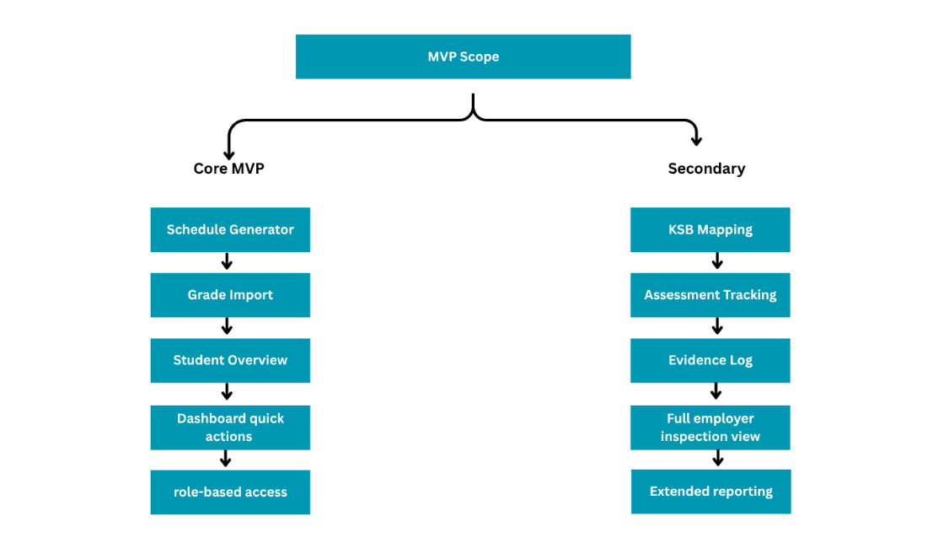
2. Technology Stack
 | Technology | Purpose
Frontend
Frontend | React | Component based UI framework
UI Styling | Tailwind CSS | Responsive styling
Reporting | ExelJS/ xlsx | Excel generation and file reading from clients end.
Dashboard | Recharts | Data visualization- bar charts, area charts, radar charts
Validations | React Hook Form | Validation and Form state management
Backend
Backend | Node.js | JavaScript runtime for API server
Routing | Express.js | HTTP routing, middleware and REST API framework.
Authentication | JSON Web Tokens | Stateless authentication tokens
Reporting | ExcelJS | Excel report generation (grade reports, schedule export)
 | PapaParse | Server-side CSV parsing for grade imports
 | Multer | Multiple file upload handling
Database
Database | SQLite | Single file database and zero configuration

3. User Roles & Access
The identified roles represent different mental models and different frequencies of use. Programme leads need cross-programme overview, academic staff need efficient operational update tools, coaches or mentors need low-friction progress visibility and feedback submission, and employers need a narrow, confidence-building window into progress and evidence. Designing all personas into the same interface requires careful control of complexity.
Role | Access Level | Key Capabilities
Programme Lead | Strategic Read & Write | Dashboard Analytics, quality management, staff overview, report generation and download
Academic Staff | Full Operational Access | Grade import, generate schedules, KSB mapping, manage assessment, evidence upload
Employer/ Mentor | Limited Access | View learner progress, submit feedback
Coach | Read Only Inspection | Evidence library review, compliance scores and quality review
Administrator | Full System Control | Manage users, role assignments, security settings, system maintenance and full audit log access

4. Functional Requirements
Based on MVP priority Schedule generator, grade import and student overview are considered as the core, while the rest of the modules are documented and treated as secondary features.
Dashboard
Role | Key Capabilities
FR-D1 | System should display key programme metrics: module count, at-risk learners, pending marks, KSB coverage %.
FR-D2 | System should show recent activity feed: evidence added, grades imported, schedule generated
FR-D3 | System should provide quick actions: schedule generation, grades imports, view KSB gaps, export report.
FR-D4 | System should allow user to do search via search bar.
FR-D5 | System should display pending assessment marking task
FR-D6 | System should display module progress

Schedule Generator
Role | Key Capabilities
FR-S1 | System should allow user to inputs academic year, semester start, and holiday periods (Christmas/Easter).
FR-S2 | System should calculate teaching weeks by excluding break ranges.
FR-S3 | System should map modules to available slots
FR-S4 | System should allow to export schedule as .xlsx
FR-S5 | System should flag bank holidays and reading weeks
FR- S6 | System should generate a weekly schedule.

Grade Import
Role | Key Capabilities
FR-G1 | System should allow user to upload CSV or Excel grade files
FR-G2 | System should auto detect column mapping
FR-G3 | System should auto populate student overview
FR-G4 | System should validate grade data
FR-G5 | System should flag duplicate data
FR-G6 | System should flag missing entries
FR- G7 | System should identify at-risk leaners
FR- G8 | System should allow to export excel report

KSB Mapping

Role | Key Capabilities
FR-K1 | System should allow user to filter by modules and KSB codes
FR-K2 | System should automatically map matrix to KSB codes
FR-K3 | System should cover percentage calculation
FR-K4 | System should do gap analysis to identify under-covered competencies
FR-K5 | System should display KBS details in preview

Assessment Tracking
Role | Key Capabilities
FR-A1 | System should display assessment release date
FR-A2 | System should display assessment submission deadlines
FR-A3 | System should display Marking progress
FR-A4 | System should display the external examiner review status
FR-A5 | System should display overdue assessment alerts
FR- A6 | System should allow user to filter based on modules, semester and overdues
FR- A7 | System should highlight the count of overall assessment and pending external examiner review

Evidence Log
Role | Key Capabilities
FR-E1 | System should allow user to create evidence entries
FR-E2 | System should allow user to attach evidence files
FR-E3 | System should store mentor feedback
FR-E4 | System should maintain searchable evidence library
FR-E5 | System should display evidence library
FR- E6 | System should have filter options for categories as; governance, quality, employer, feedback, action plan, self-access.
FR- E7 | System should display readiness progress indicator

5. Database Structure
The application uses a single SQLite database file with 14 tables, foereign keys are enforced via pragma.
Users
Column | Type | Description
id | INTEGER (PK) | Unique user identifier
name | TEXT | User's full display name
email | TEXT (Unique) | Login email — must be unique across all users
password_hash | TEXT | bcrypt hash of user password
role | TEXT | One of:  · programme_lead  · academic_staff  · coach  · employer  · system_admin
created_at | DATETIME | Account creation timestamp

Learners
Column | Type | Description
id | INTEGER (PK) | Unique learner record ID
student_id | TEXT (Unique) | Institution student identifier (e.g. B00123456)
name | TEXT | Learner's full name
email | TEXT | Learner contact email
employer_id | INTEGER (FK → employers) | Linked employer/workplace organisation
enrolled_at | DATE | Date of programme enrolment

Employers
Column | Type | Description
id | INTEGER (PK) | Unique employer record ID
name | TEXT | Employer/organisation name
contact_name | TEXT | Primary employer contact person name
contact_email | TEXT | Primary employer contact email

Modules
Column | Type | Description
id | INTEGER (PK) | Unique module ID
code | TEXT | Module code (e.g. CS401)
title | TEXT | Full module title
credits | INTEGER | Credit value of the module
level | INTEGER | Academic level (4, 5, or 6)
created_by | INTEGER (FK → users) | User who created the module record

Enrolments
Column | Type | Description
id | INTEGER (PK) | Unique enrolment ID
learner_id | INTEGER (FK → learners) | Linked learner
module_id | INTEGER (FK → modules) | Linked module
grade | TEXT | Grade value (0–100 or null if not yet graded)
grade_status | TEXT | Pass · Fail · Not Graded · pending
at_risk | INTEGER | 1 if learner is flagged at-risk for this module

Assessments
Column | Type | Description
id | INTEGER (PK) | Unique assessment ID
module_id | INTEGER (FK → modules) | Linked module
title | TEXT | Assessment name
release_date | DATE | Date assessment is issued to learners
deadline | DATE | Submission deadline
marking_status | TEXT | not_started  · in_progress  · complete  · overdue
review_date | DATE | Internal second-marking review date
external_examiner_required | INTEGER | 1 if external examiner required

KSB mapping
Column | Type | Description
id | INTEGER (PK) | Unique KSB mapping entry ID
module_id | INTEGER (FK → modules) | Linked module
ksb_code | TEXT | KSB code (e.g. K1, S3, B2)
description | TEXT | Description of the KSB element
workplace_relevance | TEXT | Notes on how this KSB is demonstrated in the workplace

Schedules
Column | Type | Description
id | INTEGER (PK) | Unique schedule entry ID
academic_year | TEXT | Academic year label (e.g. 2025/26)
module_id | INTEGER (FK → modules) | Linked module
week_number | INTEGER | Teaching week number
session_date | DATE | Date of the session
topic | TEXT | Session topic description
created_at | DATETIME | Schedule generation timestamp

Evidence
Column | Type | Description
id | INTEGER (PK) | Unique evidence record ID
uploaded_by | INTEGER (FK → users) | User who uploaded the evidence item
title | TEXT | Evidence document title
file_path | TEXT | Server-side path to the uploaded file
category | TEXT | Governance  · Quality  · Employer  · Feedback  · Action Plan  · Self-Assess
uploaded_at | DATETIME | Upload timestamp

Feedback
Column | Type | Description
id | INTEGER (PK) | Unique feedback record ID
learner_id | INTEGER (FK → learners) | Linked learner
mentor_id | INTEGER (FK → users) | Coach or employer who submitted the feedback
content | TEXT | Free-text feedback content
employer_priority | TEXT | Priority area:  · Technical Skills  · Communication  · Project Management  · Problem Solving
recorded_at | DATETIME | Feedback submission timestamp

Sessions
Column | Type | Description
id | INTEGER (PK) | Unique session ID
learner_id | INTEGER (FK → learners) | Linked learner
coach_id | INTEGER (FK → users) | Coach who scheduled the session
session_date | DATE | Date of the session
session_time | TEXT | Time of the session (HH:MM format)
session_type | TEXT | Progress Review  · Monthly Review  · Target Setting  · Intervention  · KSB Assessment  · Workplace Visit  · Catch-up
status | TEXT | Scheduled  · Completed  · Cancelled
notes | TEXT | Session notes or observations
created_at | DATETIME | Record creation timestamp

Targets
Column | Type | Description
id | INTEGER(PK, Auto) | Unique target ID
coach_id | INTEGER (FK → users) | Coach who set the target
learner_id | INTEGER (FK → learners) | Learner the target applies to
title | TEXT | Short target description
description | TEXT | Full target detail
category | TEXT | KSB  · Assessment  · Project  · Skills Development  · Feedback  · Portfolio
due_date | DATE | Target completion deadline
progress | INTEGER | Completion percentage (0–100)
status | TEXT | On Track  · At Risk  · Complete  · Overdue
created_at | DATETIME | Target creation timestamp

Visits
Column | Type | Description
id | INTEGER (PK) | Unique visit record ID
learner_id | INTEGER (FK → learners) | Learner being visited
mentor_id | INTEGER (FK → users) | Employer/mentor conducting the visit
visit_date | DATE | Date of the workplace visit
visit_time | TEXT | Time of visit
location | TEXT | Visit location
purpose | TEXT | Purpose of the visit
status | TEXT | Scheduled  · Completed
feedback_notes | TEXT | Observations and notes from the visit
created_at | DATETIME | Record creation timestamp

Audit Logs
Column | Type | Description
id | INTEGER (PK) | Unique log entry ID
actor_id | INTEGER (FK → users) | User who performed the action
actor_name | TEXT | Denormalised actor name for display
action | TEXT | Plain-language action description
type | TEXT | info  · success  · warning
detail | TEXT | Additional context or data payload
created_at | DATETIME | Timestamp of the logged action

6. Non-Functional Requirements
Column | Description
Security | Role based access control
 | Encrypted password storage
Data Protection | Data handling compliant to GDPR
 | Data minimisation
 | Secure login access
Performance | System loads within the response time
 | Reliable processing of file uploads
 | Efficient search and filtering
 | Optimized dashboard rendering
Reliability | Grade import validation to prevent from data corruption
 | Error handling for file processing
Usability | User friendly UI
 | Minimal learning curve
 | Accessible to wide audience
Scalability | Handle increased usage without performance degradation
 | Modular architecture for future expansion
Maintainability | Update, fix patches and improvement easily
 | Reusable UI components

7. UI / UX Requirements
7.1 Design Principles
Principle | Why it matters here | Concrete UI implication
Visibility of status | Inspection-sensitive systems depend on credible, current signals rather than hidden states. | Use summary cards, row statuses, progress bars, import logs and timestamps.
Consistency across modules | Users move between dashboard, tables, uploads and evidence views. Consistency lowers cognitive load. | Keep shared page structure, repeated filter positions, consistent button styles and table behavior.
Error prevention | Grade uploads and evidence handling are high-risk tasks. | Add file-type rules, template guidance, mapping confirmation, row-level validation and clear rollback options.
Recognition over recall | Programme staff should not have to remember codes, categories or hidden rules. | Expose labels, helper text, visible status thresholds and in-screen explanations.
Trust and auditability | Users need confidence that records are accurate and attributable. | Display who changed what, when a file was imported, and whether a record passed validation.
Accessibility by default | The service may be used by a wide range of staff across devices and conditions. | Meet WCAG 2.2 AA expectations, use keyboard-friendly components and never rely on colour alone.

7.2 Layout & Navigation
- The application has the static left sidebar navigation layout across all screen.
- The width of the sidebar is fixed (approximately 192px) which includes platform logo, role filtered navigation links and user identity at the bottom.
- Navigation is set to be shallow to load for infrequent users.
- Scrollable main content area with adaptable page content using 4px padding grid.
- Stat card grid is being used in dashboard screens.

7.3 Colour & Status System
Colour | Semantic Meaning | Usage Context
Teal / #0D9488 | Primary brand, active states | Active items in sidebar, primary buttons, progress bars and stat cards
Green / #16A34A | Success, on track, passing | Assessment complete, status badge (Pass), on track learner status and evidence coverage
Amber / #D97706 | Warning, at risk, pending | At risk learner badge, pending overdue, stat cards
Red / #DC2626 | Danger, overdue, failing | Status badge (Fail), assessment overdue, at risk progress bar and error messages
Blue / #2563EB | Informational, in-progress | Info log entries, assessment in progress and stat cards
Slate / #1E293B | Primary text, headings | Entire body text, contents in table and titles of each page
Light Grey / #F8FAFC | Alternating table rows, card backgrounds | Alternative rows in tables and card backgrounds

7.4 Accessibility, Inclusion and Trust
Accessibility should be treated as a functional requirement from the beginning rather than as a final-stage audit. WCAG 2.2 remains the core external benchmark for accessible web interfaces, and government guidance makes clear that services should meet WCAG 2.2 AA and avoid relying on colour, complex layouts or inaccessible document patterns to communicate meaning (W3C, 2024; GOV.UK Service Manual, 2018; GOV.UK, 2025). That matters directly for OfstedReady because the system uses status labels, tables, upload controls and evidence files, all of which can become exclusionary if implemented carelessly.
Trust is equally important. In this project, usability is not only about speed; it is also about confidence that records are correct, attributable and protected. The team’s implementation notes already move in that direction by prioritising foreign keys, upload logging, role-based access and data minimisation. Those choices should remain visible in the interface. Users should be able to see who uploaded a file, which import batch produced a status change, and whether they have permission to edit or only to view a record (Project Team, 2026b; ICO, n.d.).
• Use colour together with text labels, not by itself. An “At Risk” item should remain understandable in grayscale, by screen reader, or for users with colour vision differences.
• Use accessible error handling. GOV.UK guidance recommends field-level errors plus an error summary for invalid submissions, which is especially relevant for uploads and date inputs (GOV.UK Design System, 2025b; GOV.UK Design System, 2025c).
• Keep data tables simple. W3C and GOV.UK both recommend using tables for real data, with clear headers and no decorative complexity; this suits the learner, module and assessment tables in the wireframes (W3C WAI, n.d.; GOV.UK, n.d.).
• Support keyboard navigation and visible focus states throughout the interface, especially in upload forms, matrix filters and table actions.
7.5 Prototype UX Implementation
Dashboard
Stat cards are being used in the first row of the dashboard as the Programme lead view every signals such as modules, learners, at risk, pass rate immediately without no deep navigation. This acts as a 4-card grid where same pattern is being reused across all roles.
Following that the left column prioritizes Programme progress chart which brings the trend at a glance, the right column is left for quick actions and recent activity so that do now task could be handled easily without leaving the dashboard.
Sidebar navigation
Static left sidebar with fixed width 192px as the users infrequent with switching roles, persistent navigation would reduce re-orientation time. Links are being filtered by role as the visibility is filtered based on the user role.
The depth of navigation is intentionally shallow whereas the MVP workflow that is being reachable in single click from the sidebar also via quick actions in dashboard. This reduces the hidden paths during demonstration and matches the research goal.
Upload workflow
The upload workflow would work as: Upload Auto detect mapping Validate rows Commit results. Using file type checks this is implemented by mapping confirmation step with a low-level validation output to prevent corruption and prevent database writing. The errors and warning counts are being displayed as validation summary banner following that a validation table list is being displayed with exact row issues allowing the staff to quickly correct source files, where the system updates student overview and writes an audit log entry parallelly.
Table/ card structure
As users need to perform task such as scanning, sorting and exporting tables are being used to display real data, which includes the status badges and timestamps allowing the inspection evidence visible.
Summary and action surfaces such as stat cards, quick actions, validation summaries are being displayed via cards so that the visual noise is being reduced and primary task are centered on the table content.
7.6 Wireframes
The below provided wireframes reflect the prototype structure by connecting the UX requirements to the implemented layout decisions.
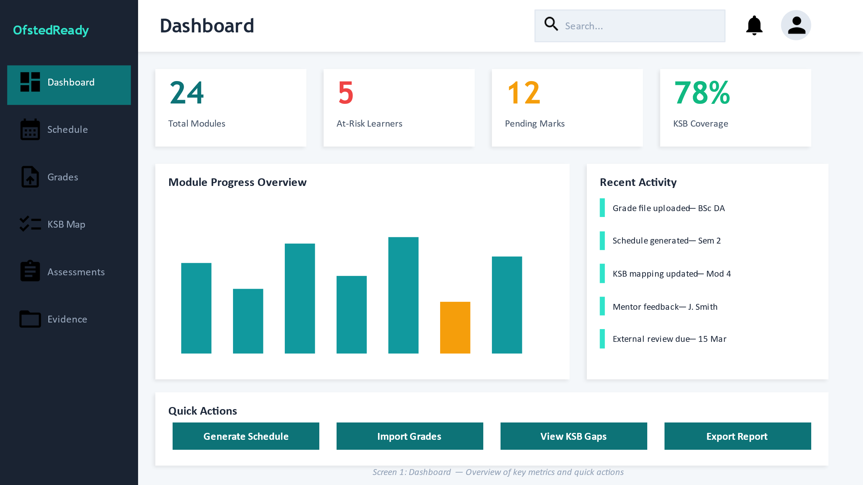  Dashboard | 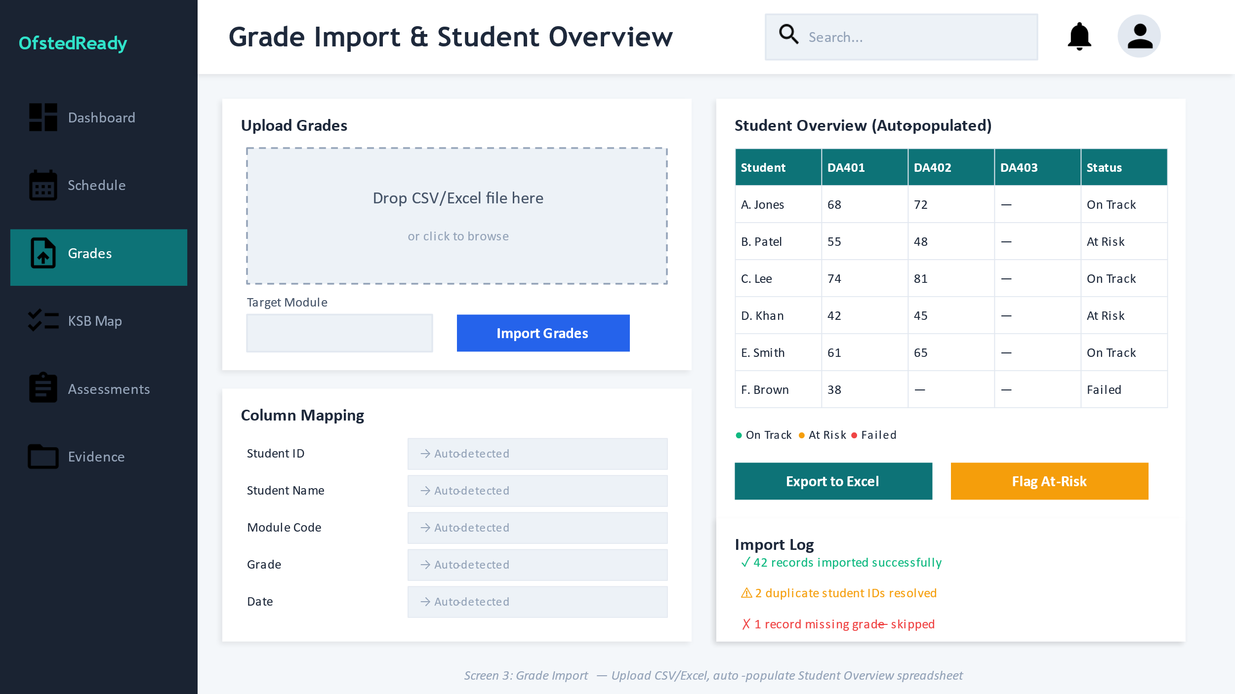  Grade Import
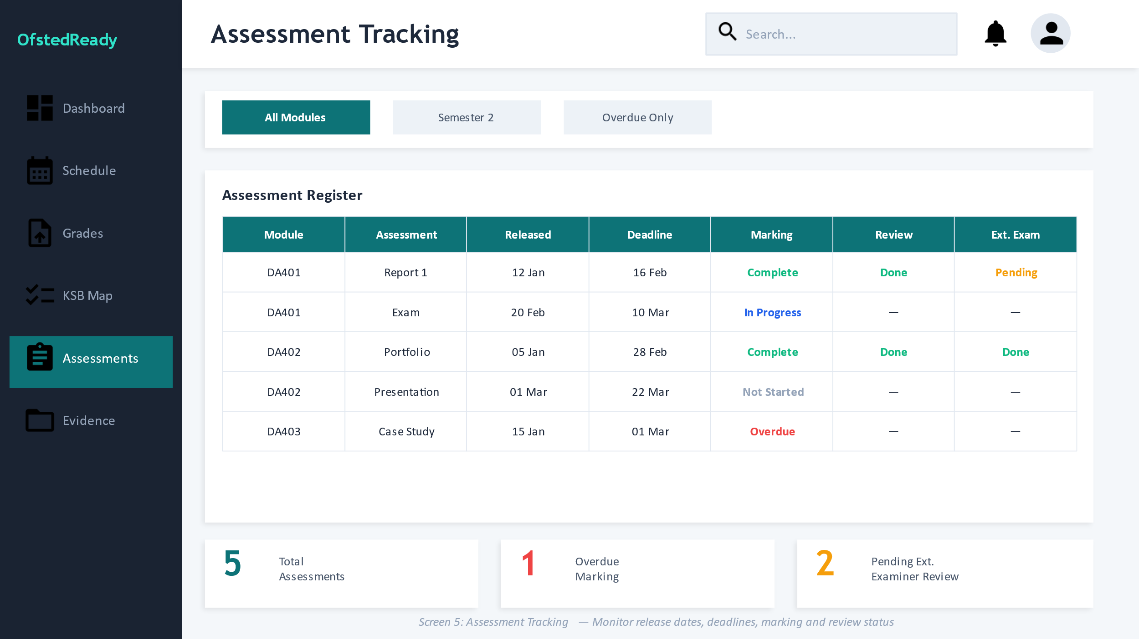  Assessment Tracking | 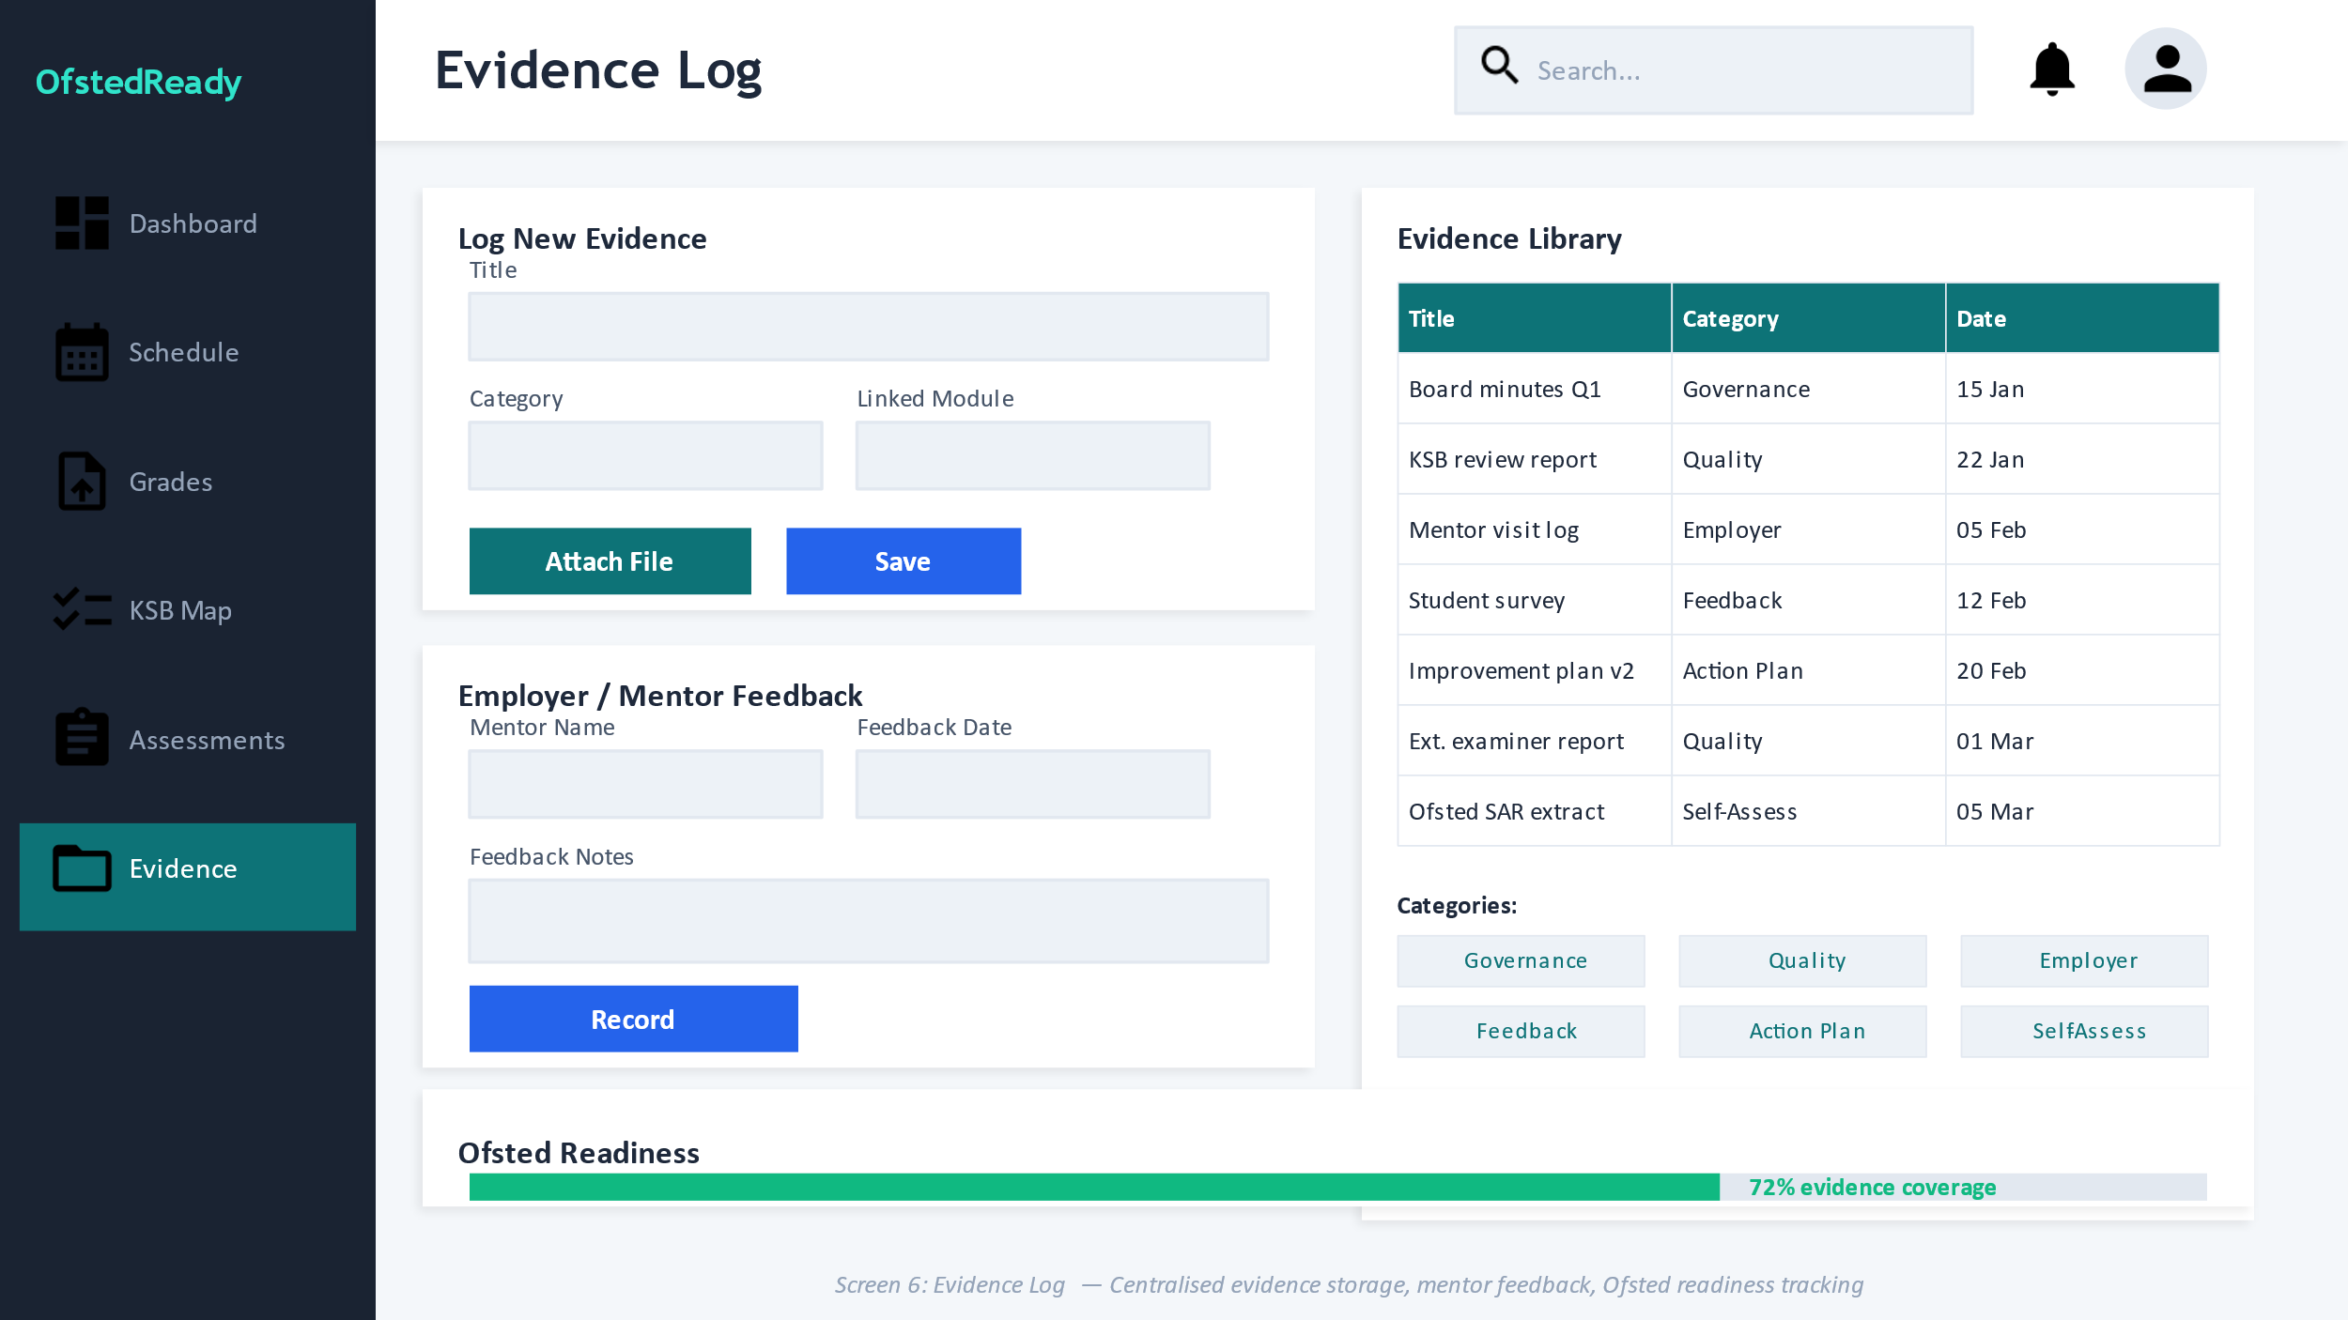  Evidence Log
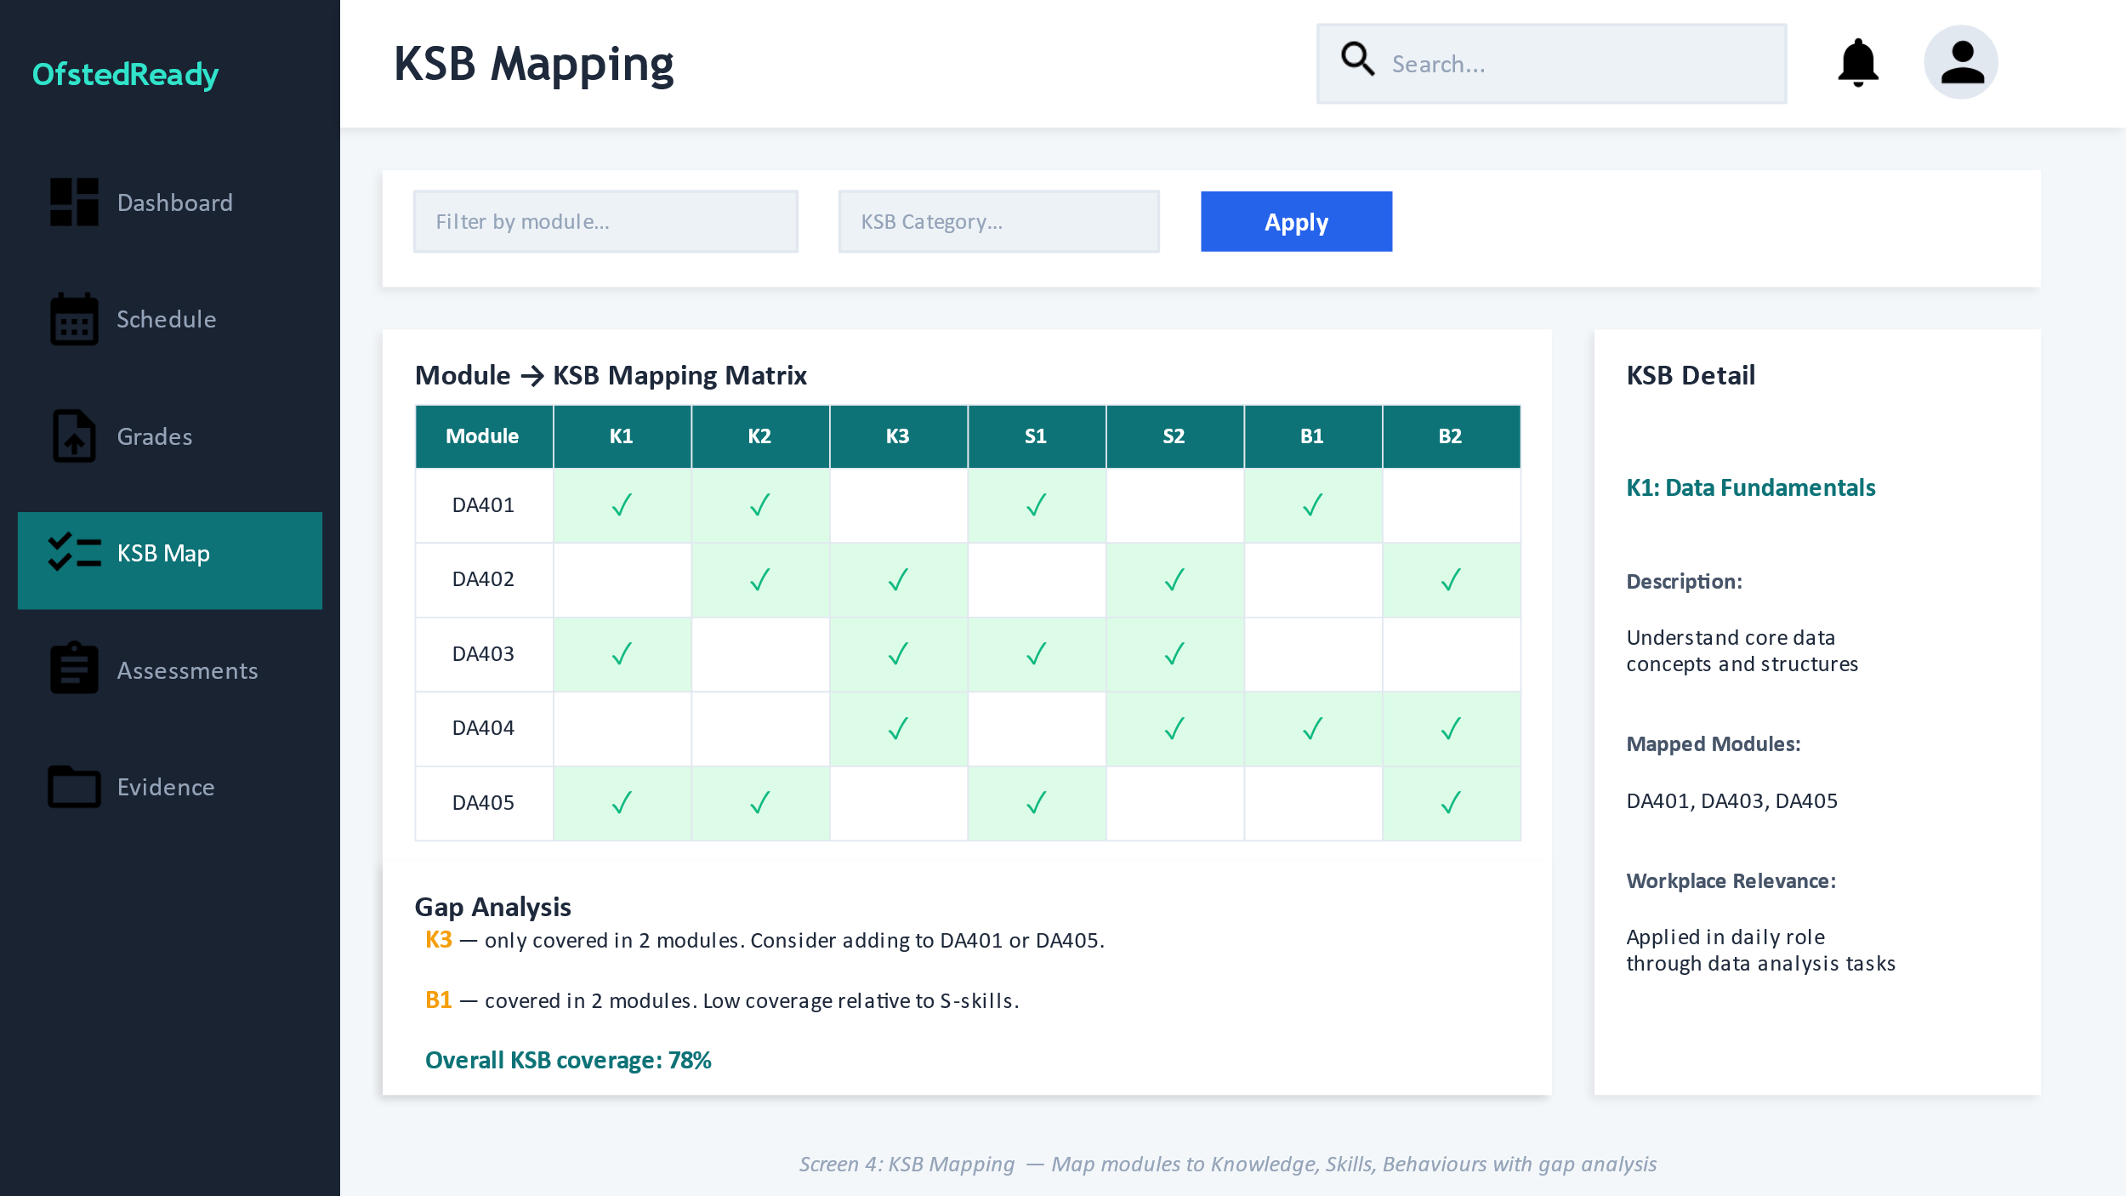  KSB Mapping | 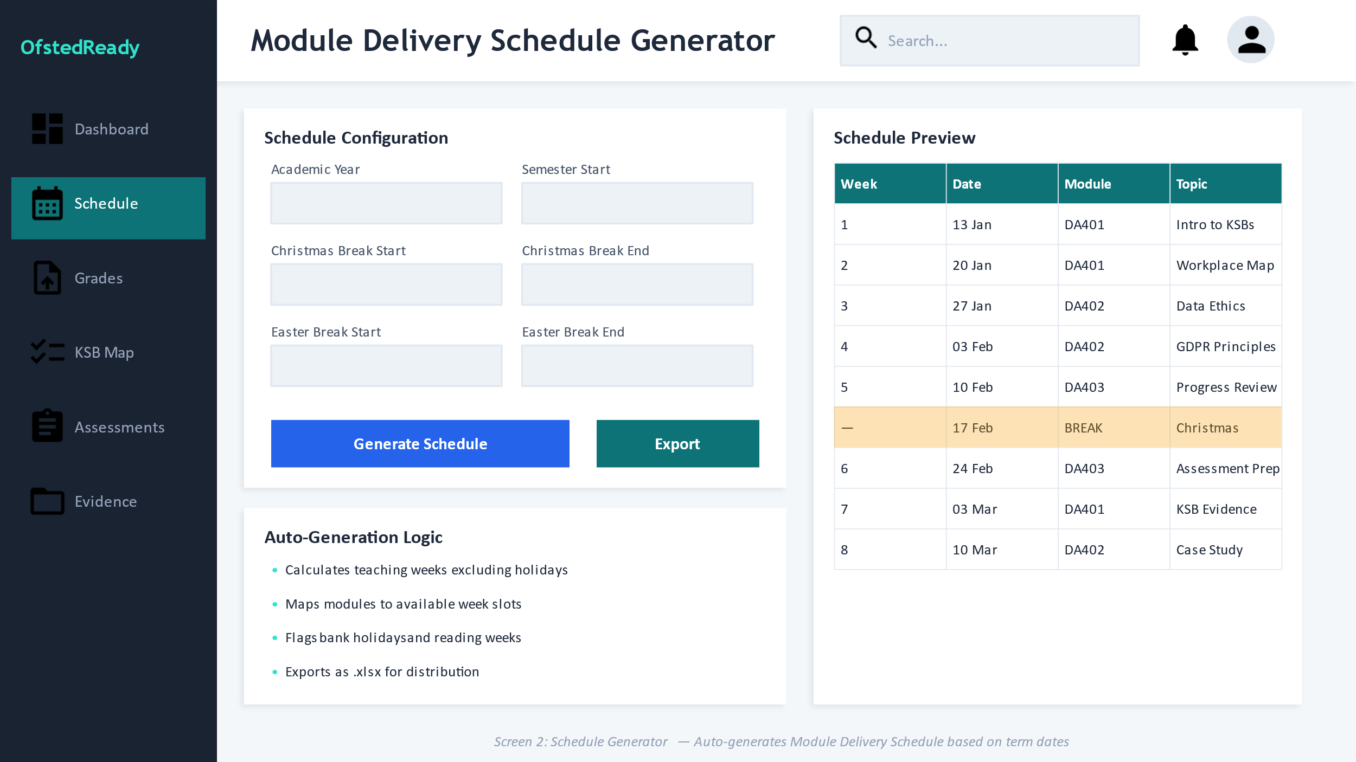  Schedule Generator
7.7 User Flow Diagram
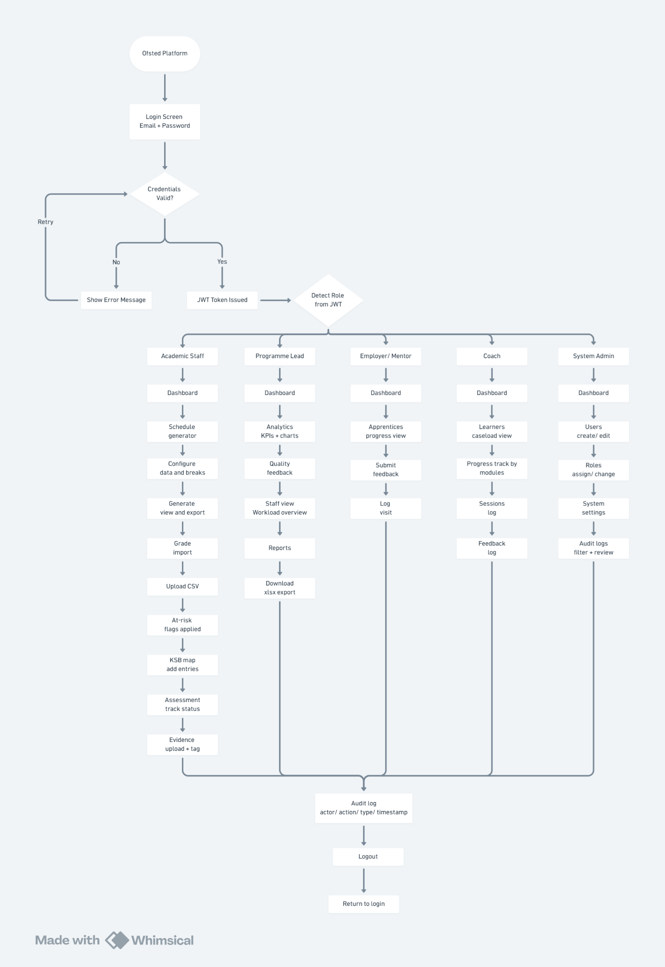
7.8 Final UX Design Decisions
Colour
The prototype owns a Teal as the primary colour by avoiding mixed hierarchy, while rest as green, amber, and red are being reserved for outcomes. For in-progress state blue is being used as slate remains the dominant text colour.
Navigation
The sidebar navigation remains same across all the screens with current route highlighted and links role filtered. Quick actions in dashboard allow user to start task immediately.
Usability choices
Prioritizing consistent pages with title, helper text, primary action area and table output. Filters/ search bars are always placed above the table; text is being always included in the status badges.
Validation logic
Layered validation is used in grade imports- file type check, required column check, confirmation mapping, row level rules. Blocking invalid rows and importing valid rows. Schedule generates validates date ranges, overlapping holiday periods, and prevents generating teaching weeks inside excluded ranges before export.

Development
8.1 System Features and Screen Guide
8.1.1 Academic Staff
Dashboard
The dashboard of academic staff appears as the first screen after login, it provides all the operational urgent information as at-risk learners, pending grades, upcoming sessions and module level evidence counts. This makes sure nothing important is missed before navigating to a specific task. Quick action buttons allow the staff to navigate quickly for the most frequently used features.
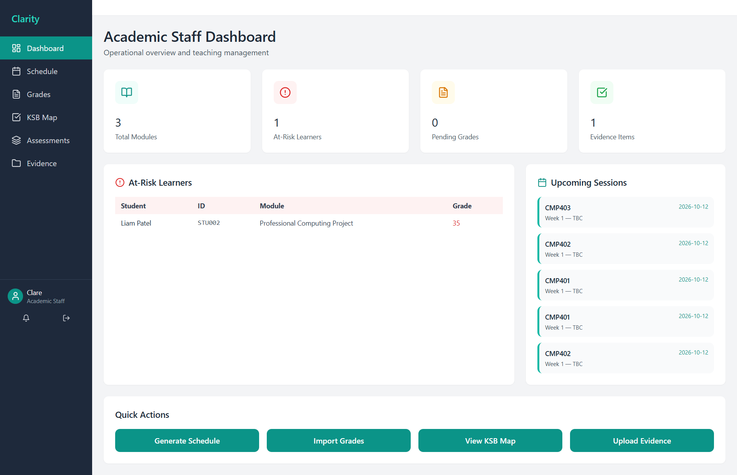

Schedule Generator
The schedule generator feature automates the creation of full academic year timetable. The staff configures the semester date range and all holidays exclusion periods, so the system generates week by week session per module. Generated schedule table is displayed as week number, date, module code and topic. Export CSV button allows the staff to download full schedule as a spreadsheet.
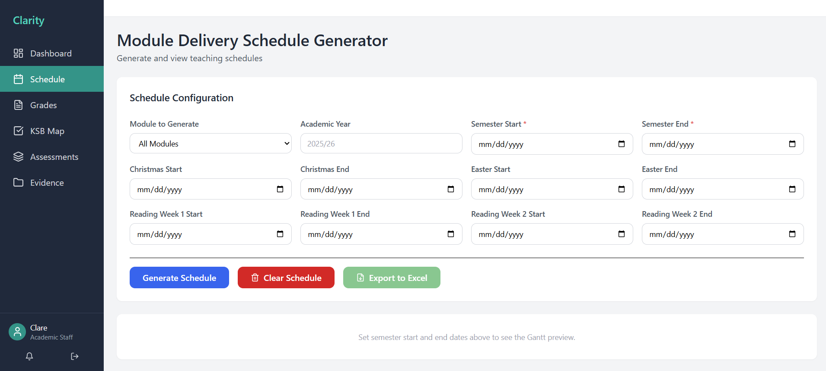
Grade Import
The core data entry workflow would be grade import, the staff uploads the CSV file, the system validates every row and maps student IDs to database records and automatically calculates pass/ fail and then flags the at risk to learners below 40% threshold. Student grade overview table automatically refreshes after importing and displays student ID, name, grade, status.
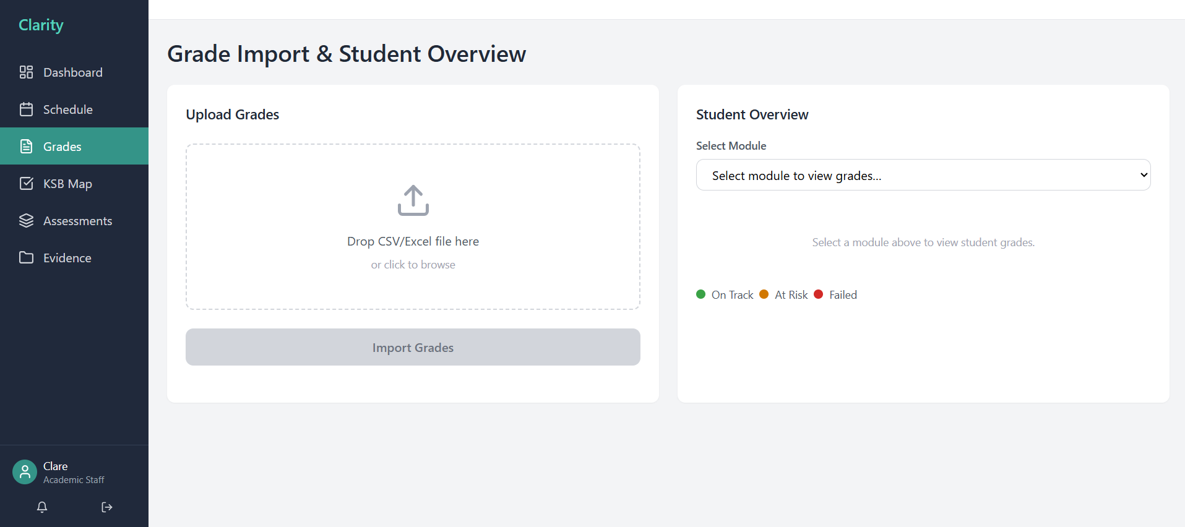

KSB Map
The KSB Map acts as the curriculum coverage tool, through this matrix the academic staff view three KSB dimensions covered by each module, with an automatically calculated coverage percentage and gap identification.
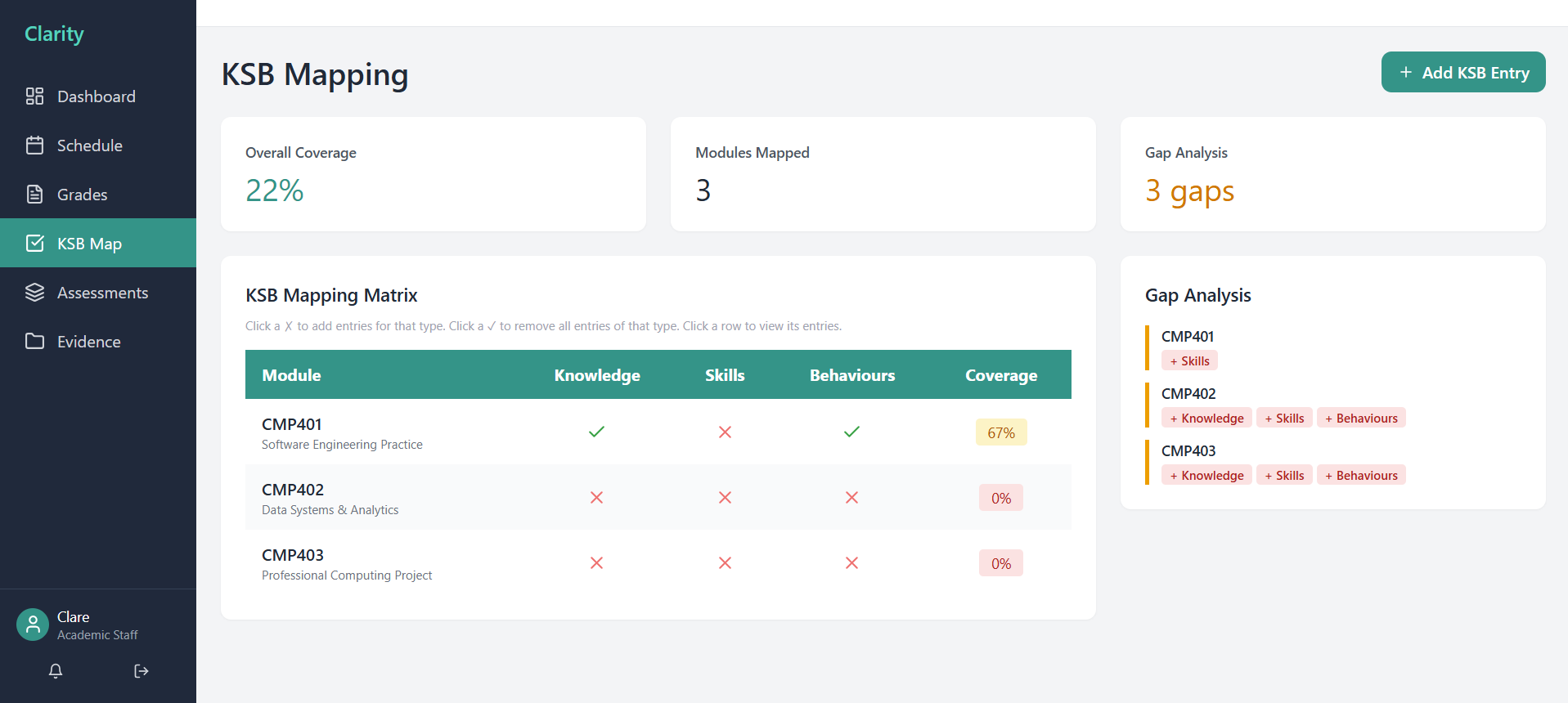
Assessment
Assessment screen provides all assessment deadlines, marking progress, review dates, external requirement across modules. This makes the work easier as there is no need of separate tracking spreadsheets. Add assessment allows to create new assessments with all necessary fields that directly populates in the screen after saving.
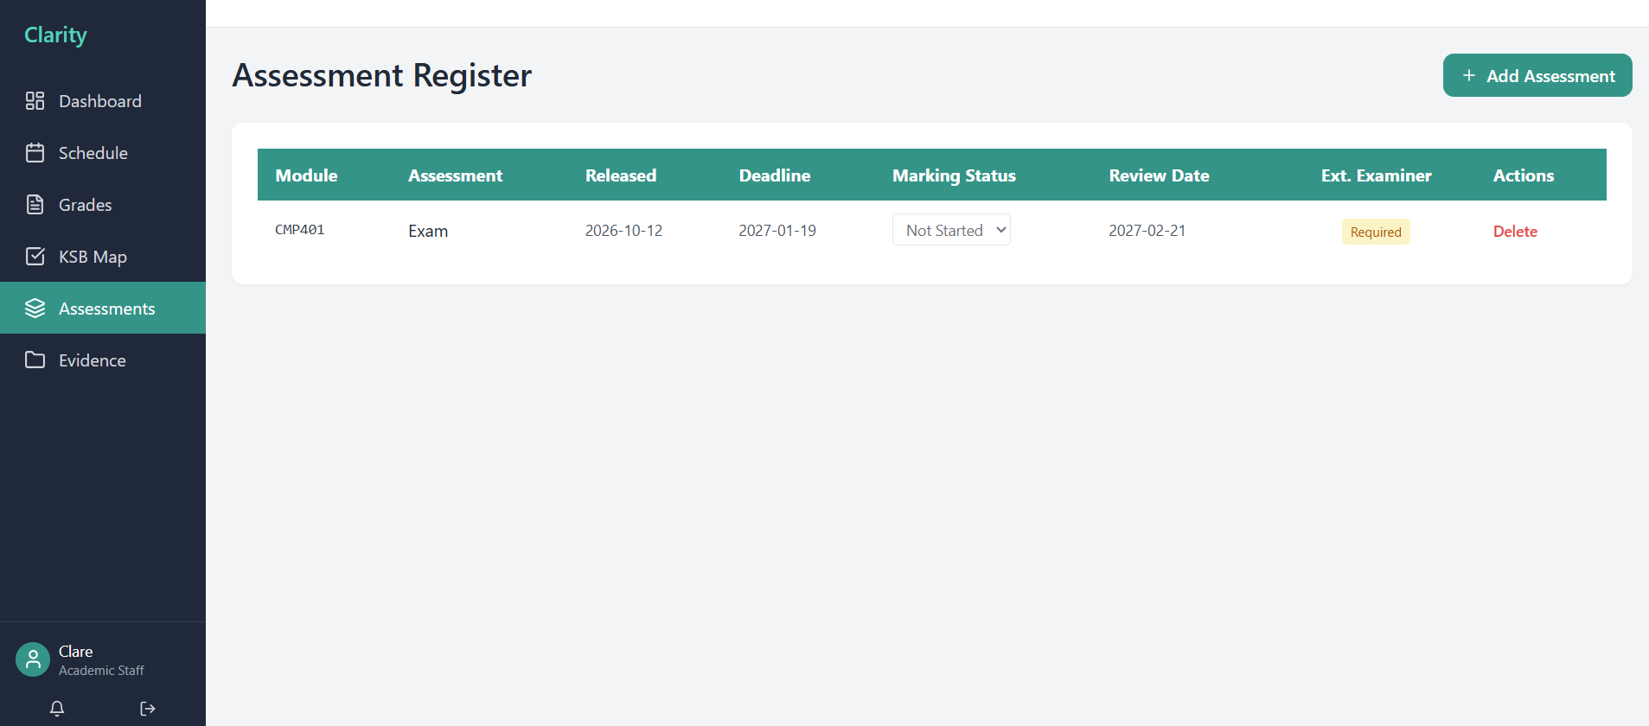

Evidence log
The evidence log acts as a library, with a searchable and categorized store of all uploaded evidence documents (quality reports, employer engagement records, learner feedback, governance, quality and self-assessment). The evidence could be uploaded by selecting the title, category and attaching the file, the uploader’s name is automatically timestamped. The real time filters under evidence library are based on categories and titles (Works with no submit button.)
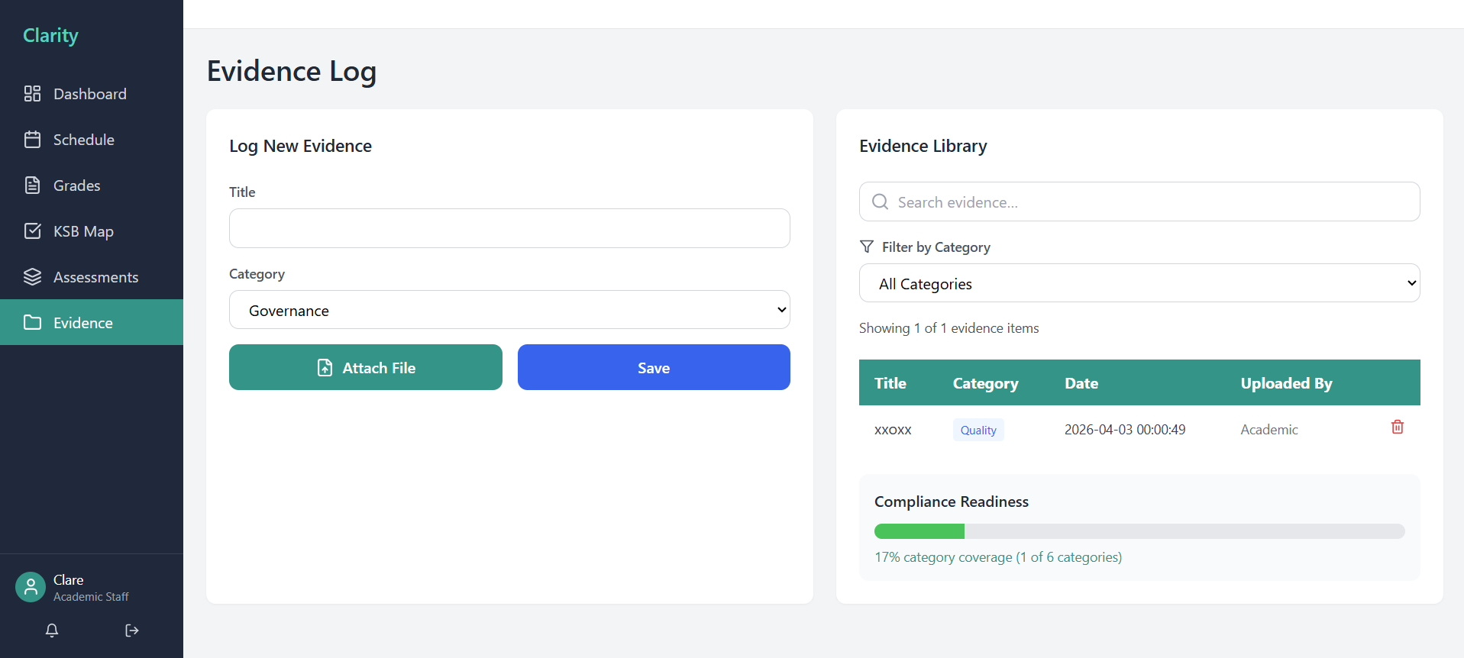

8.1.2 Programme Lead
Dashboard
The dashboard of the programme lead provides a strategic overview, by focusing programme wide pass rate, at risk learners counts, module health and quality signals by giving the programme leaders the exact data they need to improve planning and Ofsted readiness.
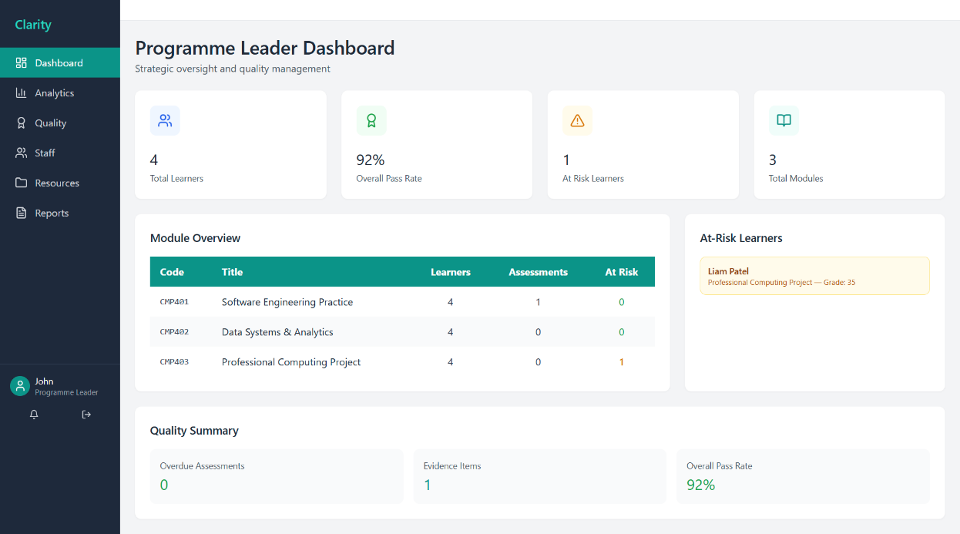
Analytics
The analytics page provides a wide range of visual representations of the programme performance. The charts provide the programme leader with spot trends, compare cohort and identify underperforming modules along with evidence for better decision making of Ofsted.
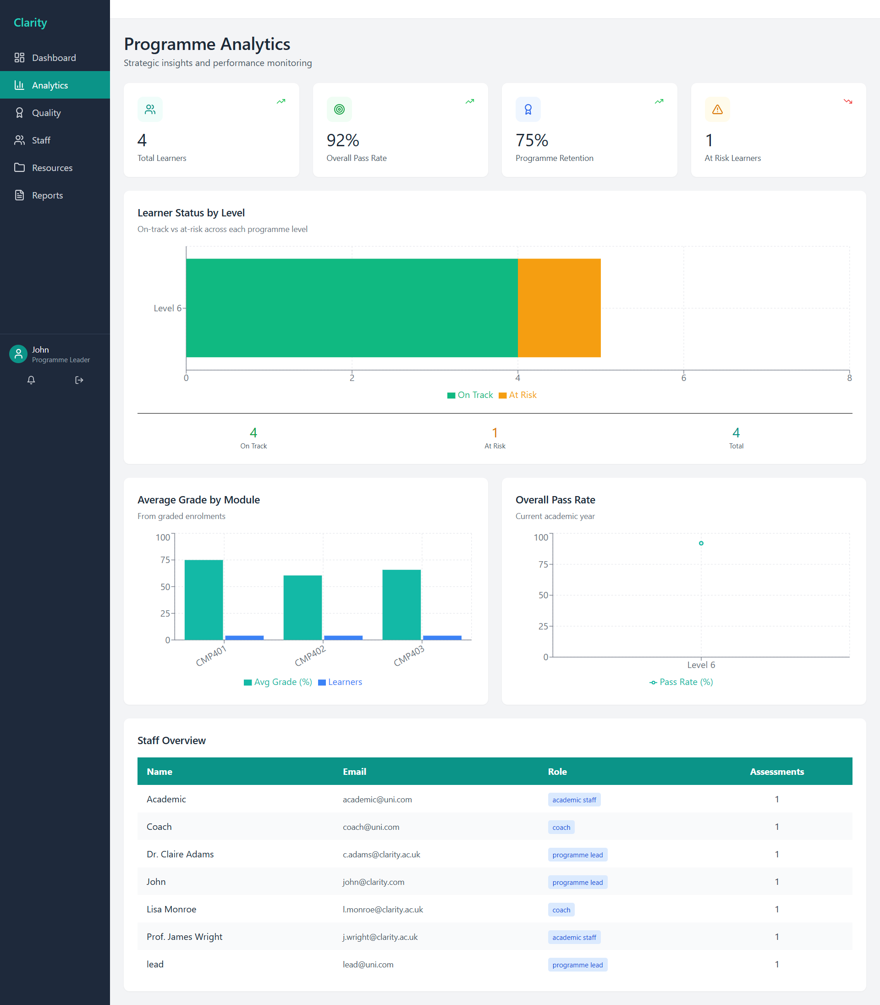
Reports
The report page provides a pre-built report templates that the programme leader could download as excel from live database, generate an new report if needed. Reports act as the primary output for sharing performance of the programme of senior leadership and stakeholders when needed.
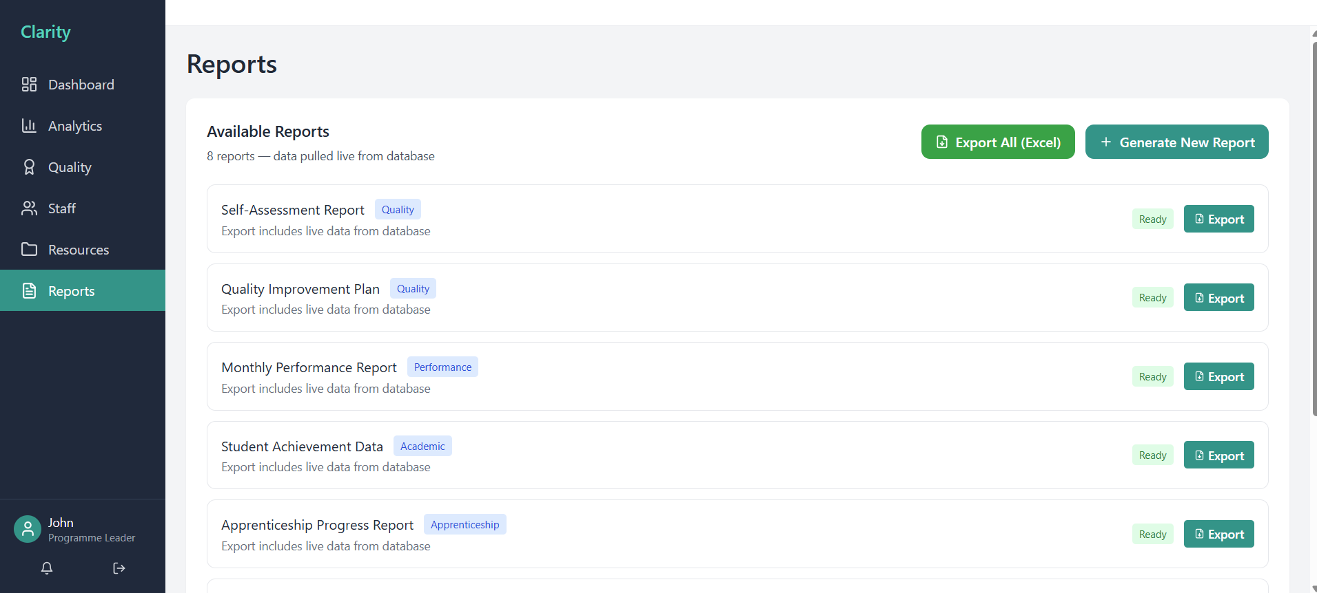
8.1.3 Mentor
Dashboard
This dashboard for mentors provides a simple and focused view the linked progress, feedback submission form and summary of recent feedback that have been submitted. No grade data, user management or system configuration is accessible for this role.
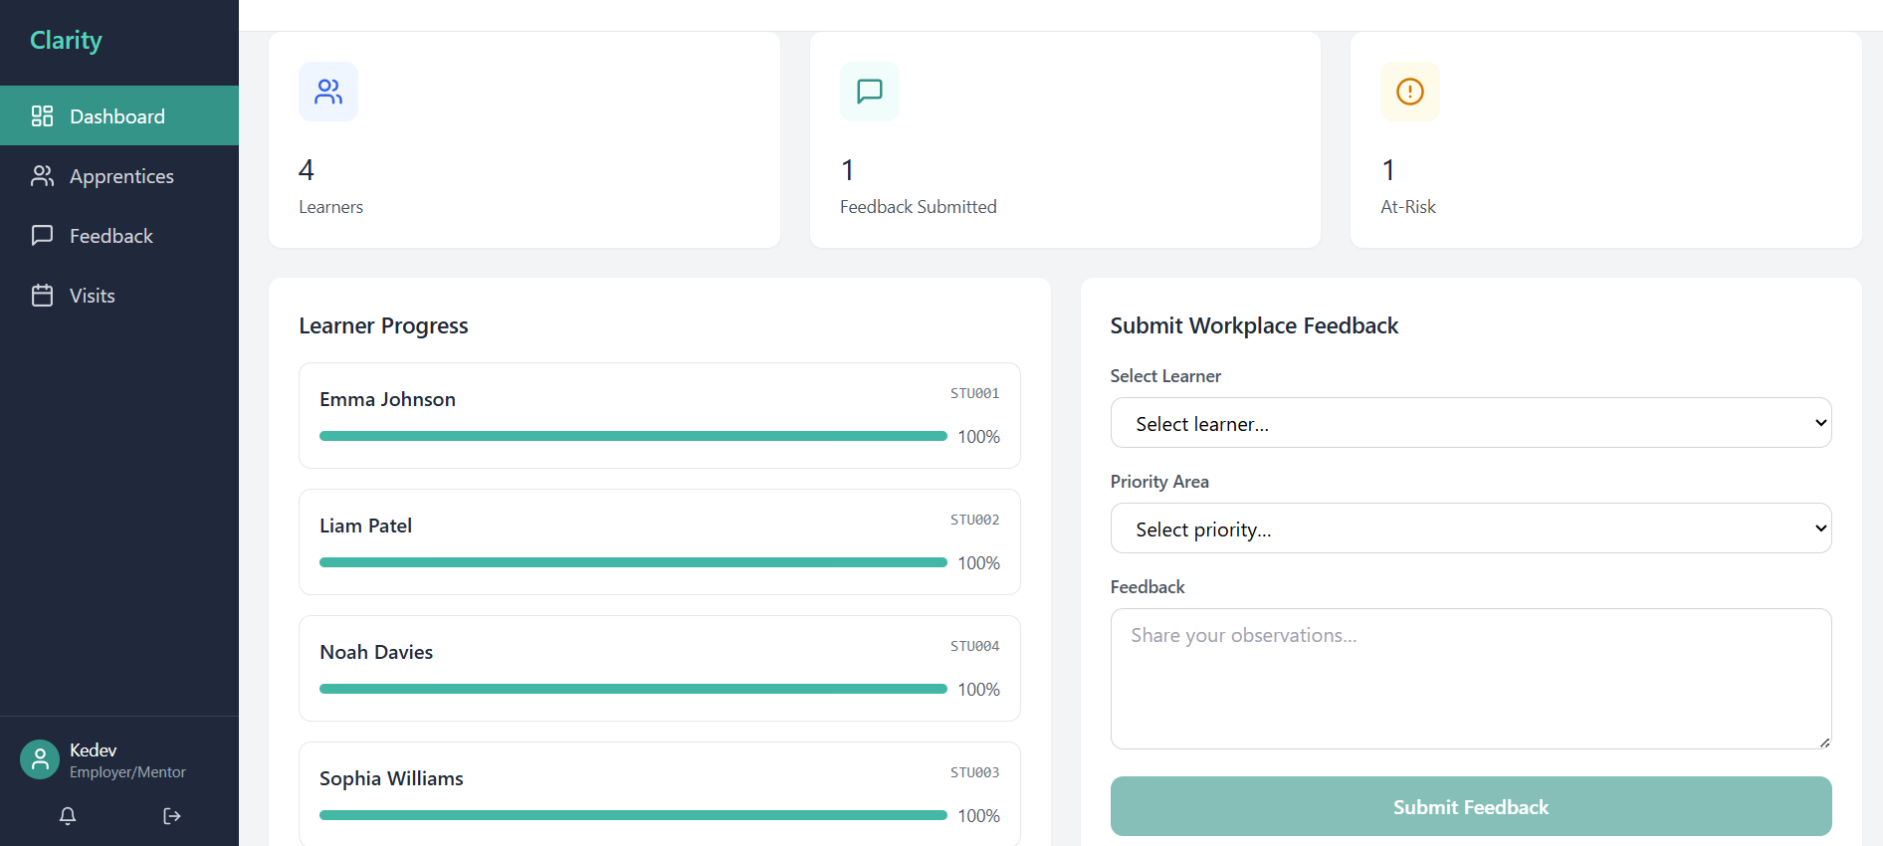
Three stat cards indicate learners, feedback submitted and at risk. Learner progress card shows each apprentice’s name, student ID and colour coded progress bar with read only capability. The inline feedback form allows the mentor to select learner, choose priorities are (Technical skills, communication, project management, problem solving), free text observation and submit. This would immediately appear in the apprentices and get stored in the system. Mentor can also submit the feedback by navigating to the feedback tab.
Visits
This page allows the mentor to log workspace visits and observations, as these records would be visible to the linked apprenticeship coach for coordination and included in audit trial for Ofsted evidence purpose. Schedule visit button allows the mentor to select leaner, enter date, choose visit type and record observational notes. The status of the visit record would be as scheduled and completed, all these visit records are being timestamped and store in database.
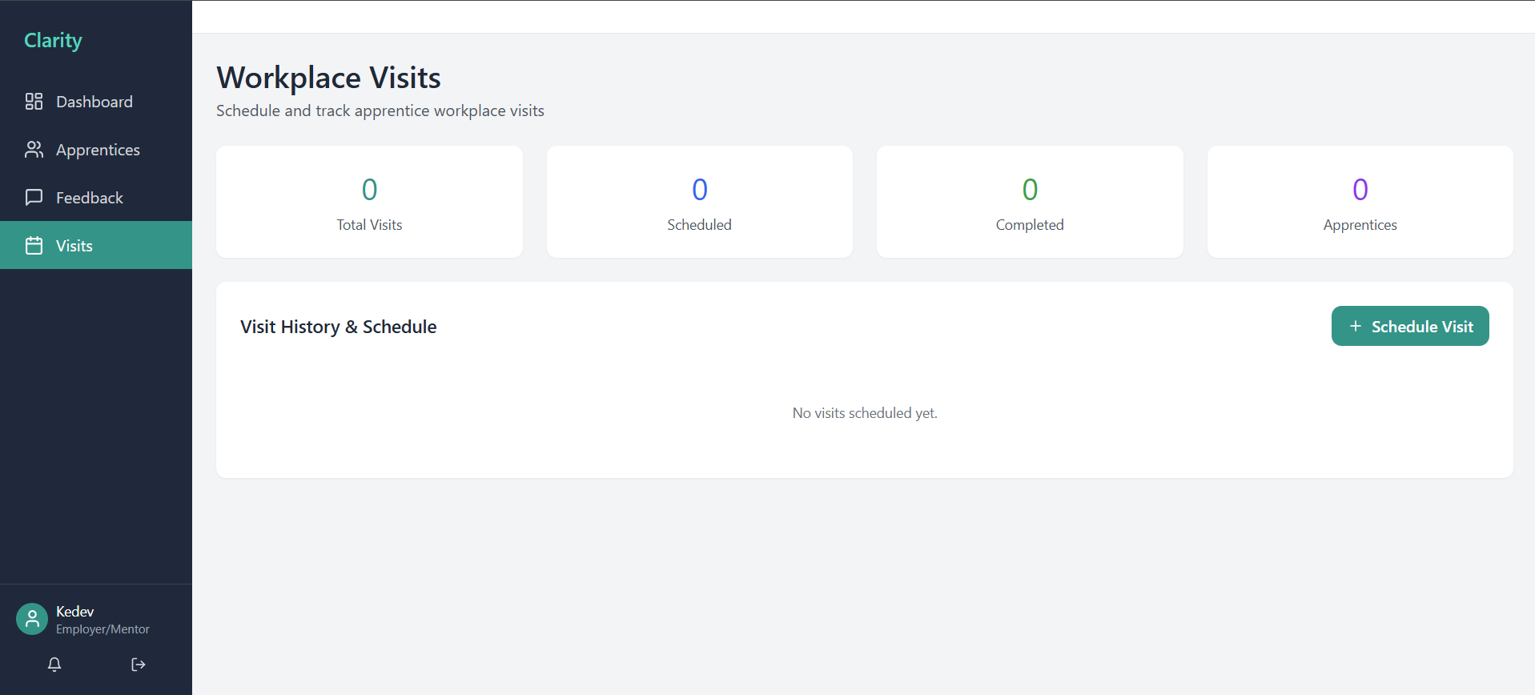
8.1.4 Coach
Dashboard
The dashboard of the Coach is based on coach’s assigned caseloads, provides immediate visibility of learner progress, upcoming sessions (lists out the next five scheduled sessions with learner name, session type, date and time) and recent feedback. This allows the coach to support each apprentice effectively.
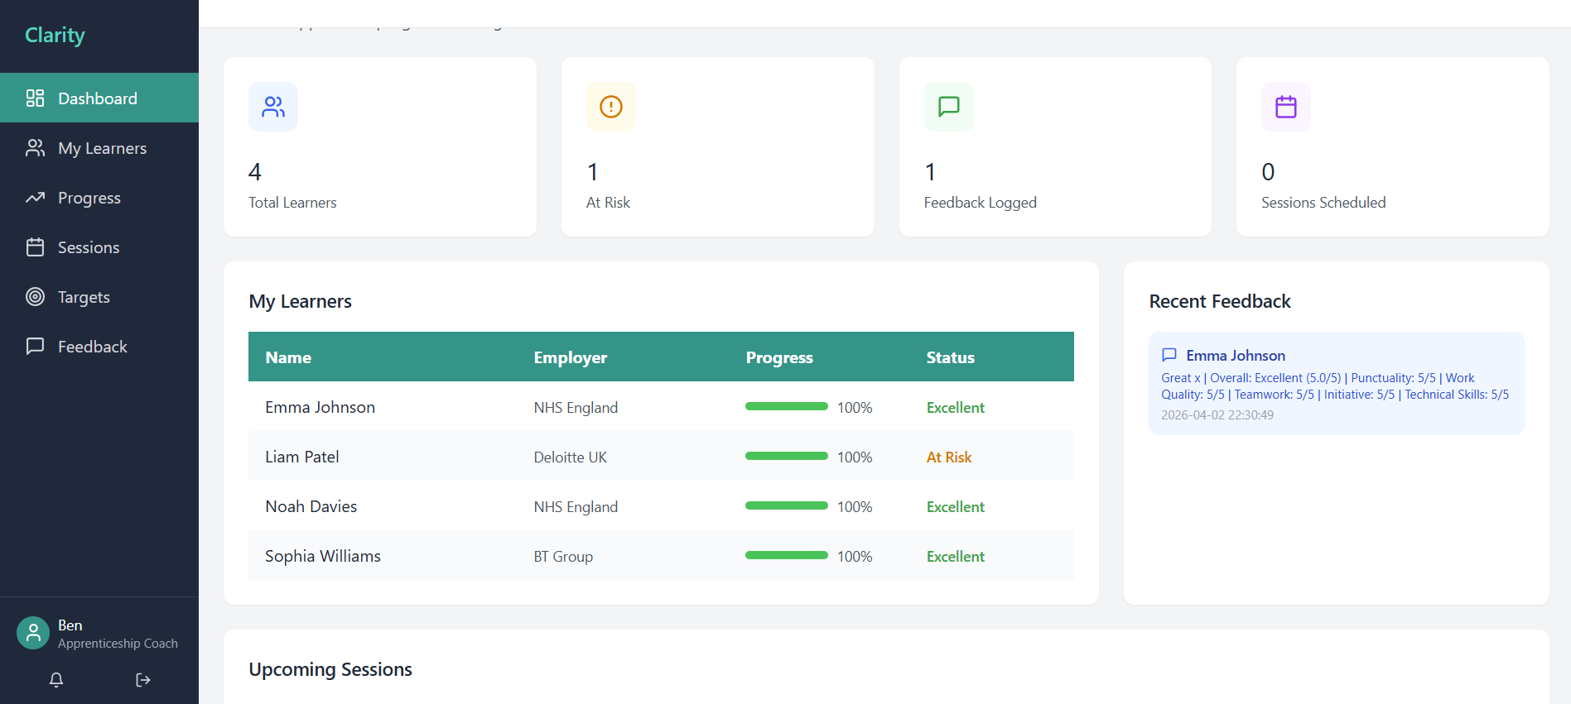

Sessions
This screen allows the coach to schedule, log and manage all coaching sessions with learners. This session type covers the full range of review activities from monthly routine reviews to formal interventions. The session table columns include Learner, Student ID, Date, Time, Type, Status (Scheduled / Completed / Cancelled), Notes. When the coach clicks on schedule session button allows coach to select learner, set date and time, choose session type, and add notes. ll the sessions are sorted by date with upcoming sessions prioritized and this allows the coaches to always see what is coming next.
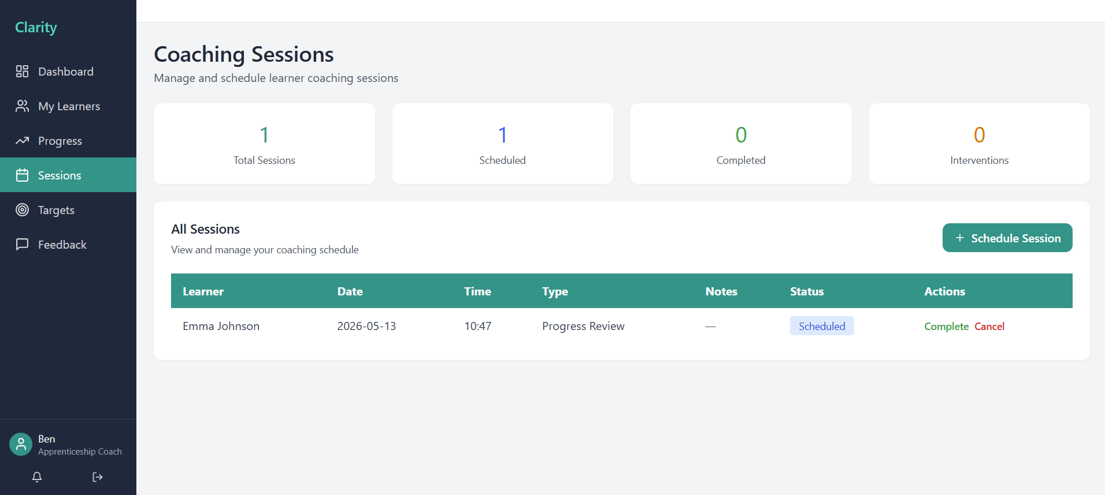
Targets
This screen allows the coach to see a structure, time bound targets set up for each learner and track progress against the learners. The targets are being categorized based on type and automatically a status is being derived (On track, at risk, complete, overdue) based on the due date and progress percentage. The add target collects the learner, title, category, due date to have a meaningful tracking.
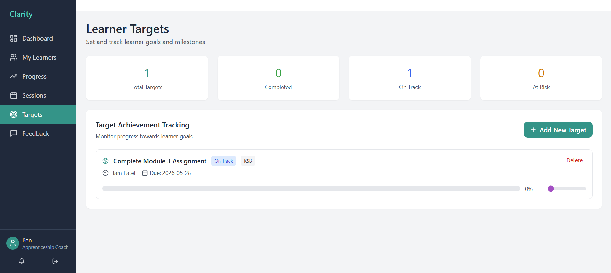
8.1.5 System Administrator
Dashboard
The dashboard of system administrator gives a complete overview of user count by role, accounts recently registered, sum of learners, modules and evidence items. Quick action buttons are being provided for easy navigation to all administrative functions.

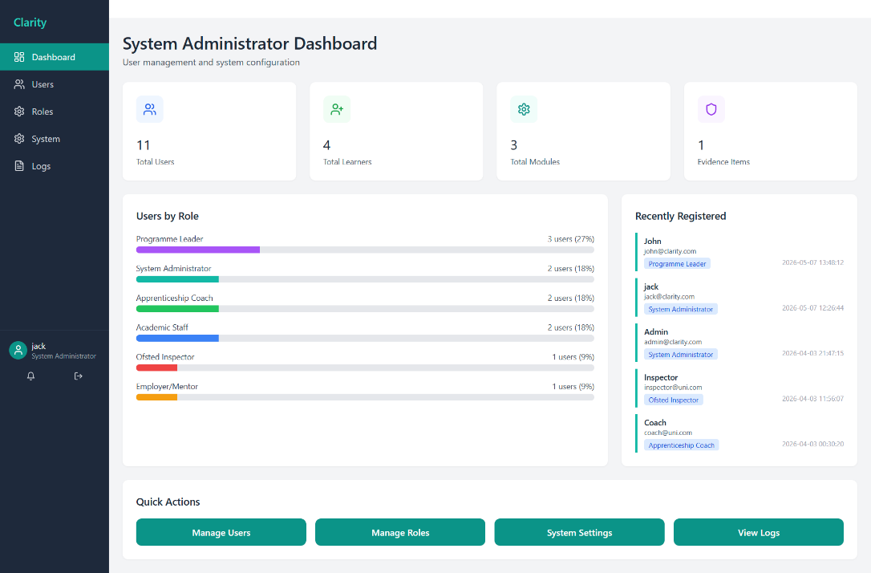
User Management
Users page allows the admin to manage all the user accounts, administrators can create, search, edit, and delete any user account. The role displayed on each account indicates what the user can do across the platform. Add new user form, allows to create a new user by providing full name, email, role and password, email must be unique across system.
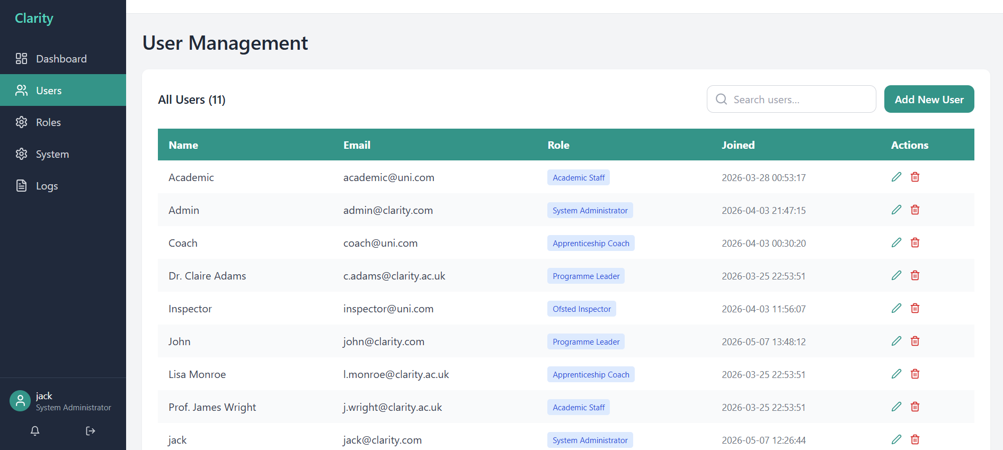
Role Management
All users by their assigned roles are being displayed, the system allows administrator to reassign any user to different role. This would be the main screen for onboarding new staff to the correct access level based on the role.

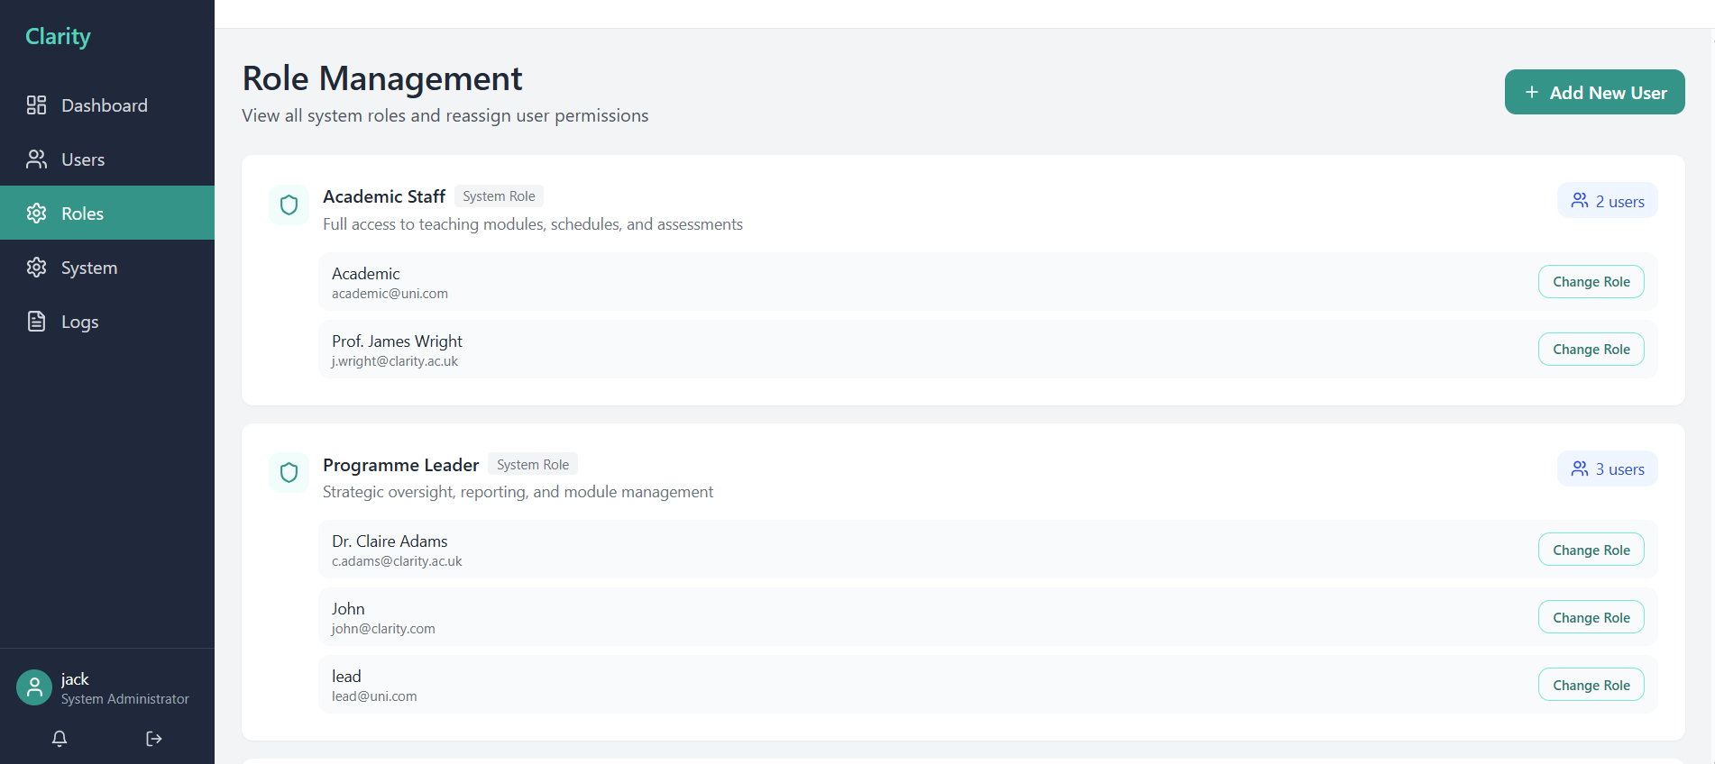
Audit Logs
The system logs screen provides a live filterable trail of every meaningful write operation across the entire application regardless of the roles. Starting from visit logs, grade import, evidence upload, user creation, role change, session schedule would appear in the screen with timestamp.
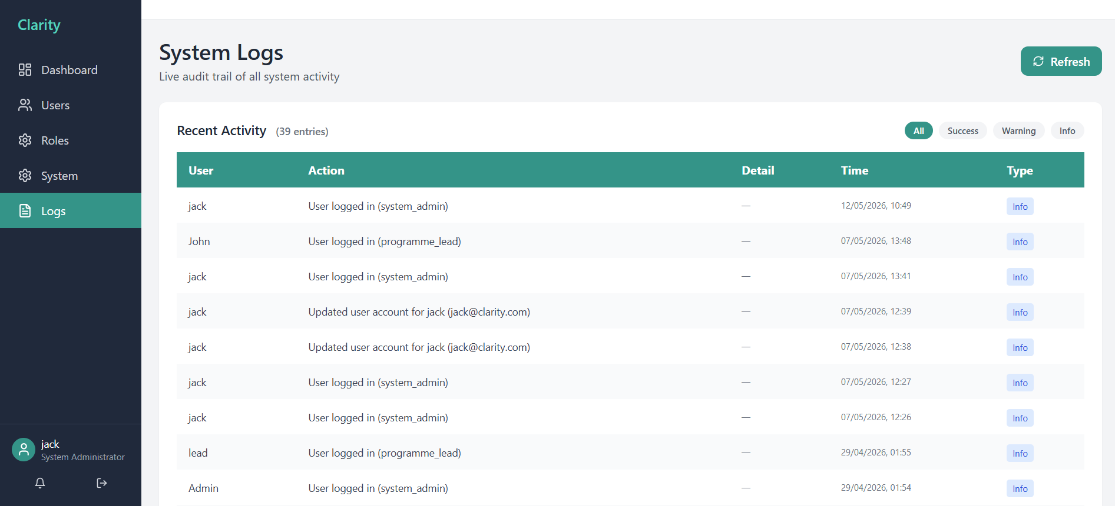

8.2 Code level explanation
8.2.1 Login Route
The login route handles all the credential validations and token issuance. This would be the entry point for all users within the platform.
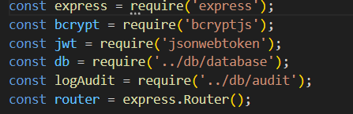
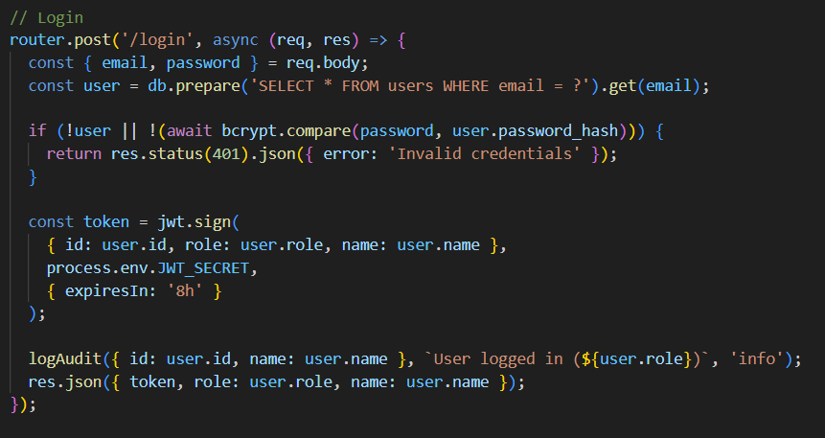
The line bcrypt.compare () Compares the plain-text password from the request against the stored bcrypt hash, this is always constant time to prevent timing attacks. 401 returns unauthorized for both user not found and wrong password with same error message by preventing user enumeration. Jwt.sign () creates a signed token which is embedded in user id, role and name. JWT_SECRET reads from environment variable, logAudit () this provides a complete trial for system inspection taceability.
8.2.2 Grade Import
This module acts as the most critical feature of the platform, the staff would upload CSV exported from the marking system while this system validates, maps and persists the grade data by flagging the at risk learners in the same time. The parser handles CSV file formats by normalizing column names and stripping whitespace before returning a consistent array of row objects.
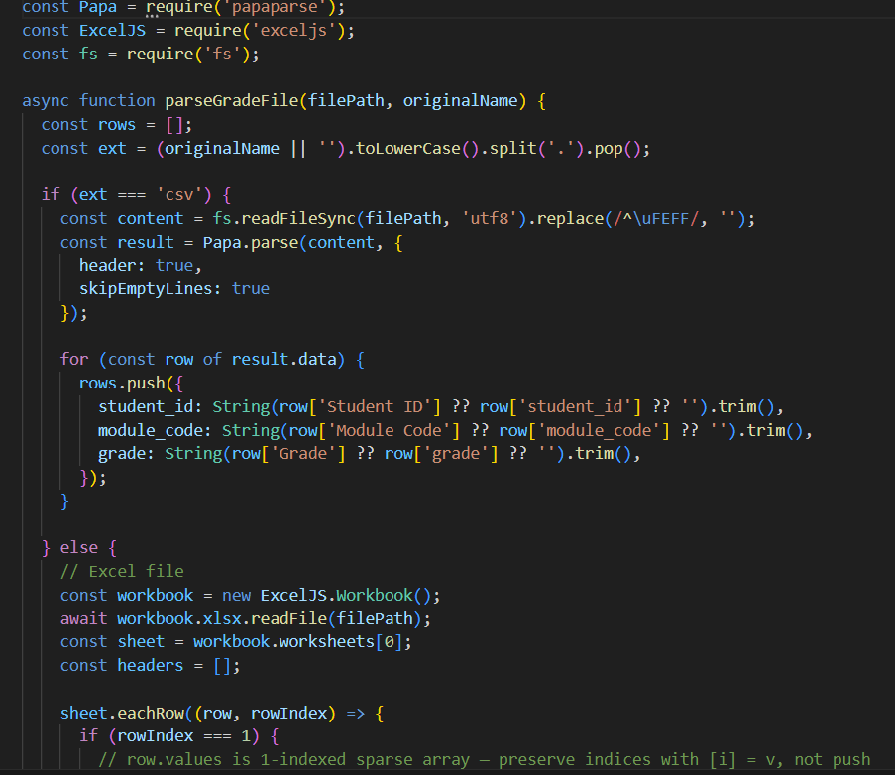
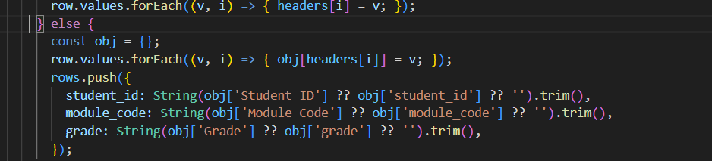
.replace(/^\uFEFF/, '') Strips the BOM (Byte Order Mark) that Excel adds to CSV files when saved on Windows. ?? fallback operator - The nullish coalescing operator (??) accepts both title-case ('Student ID') and lowercase ('student_id') column names, by making the system tolerant of different export formats from different marking tools. Trim () Removes leading whitespace from all field values. PapaParse is a CSV parser that correctly handles quoted fields with multiline cells and commas inside values. Excel JS eachRow indicates that row 1 would be header and the rest as data. Return rows allows both branches produce same data shape.

8.2.3 Schedule Generation Engine
Schedule generation engine automates the creation of full academic year teaching timetables, by providing semester date range and holidays exclusion periods, this iterates week by week by excluding all holidays and assigns a session to each active module for every teaching week.
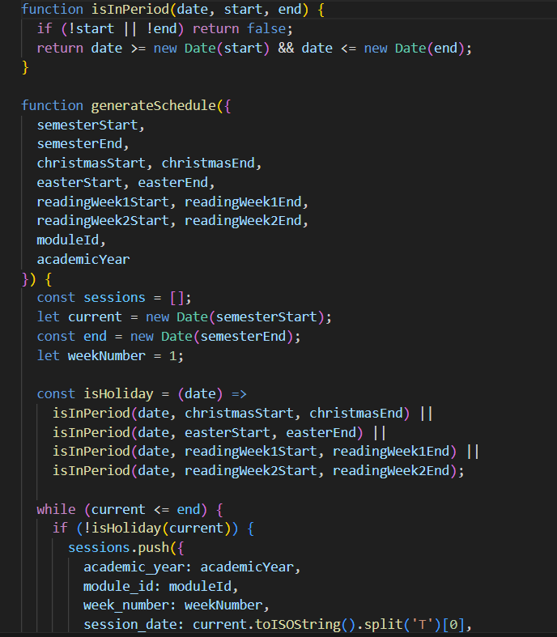
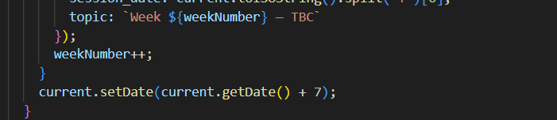
isInPeriod() function helps to check whether a date falls within a start/ end range, returns if either bound is missing.current.setDate(+7) advances the loop by exactly 7 days on each iteration, weekNumber++ function reflects the first teaching week not calendar weeks, regardless of where in the calendar it falls. The function .toISOString() .split (‘T’) [0] converts the javascript to YYYY-MM-DD string format.
8.2.4 Frontend API service
Every API call from frontend (React) flows through a single api.ts service module, which centralizes to ensure JWT token are consistently attached, errors are uniformly handled and responses are provided by typescript.
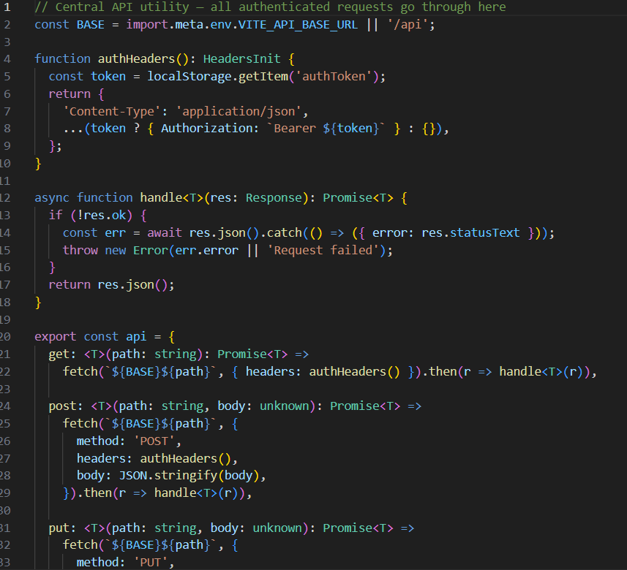
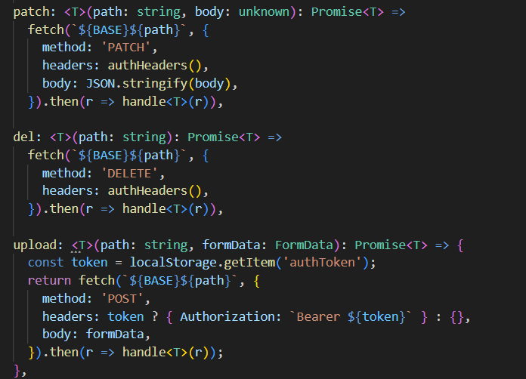
authHeaders () ensure that if the user logs out and a new user logs in , the new user’s token is user not the previous one. Generic <T> this Typescript allow callers to declare the expected response type by checking all property accesses against the declared type. Upload() no Content-Type supports File uploads using FormData.
8.2.5 KSB coverage map
The KSB Mapping provides curriculum coverage from raw database entries, as the frontend derives a coverage matrix by grouping KSB entries by module and checking for the presence of K, S, and B prefixes as no pre-computed coverage column exists in the database.
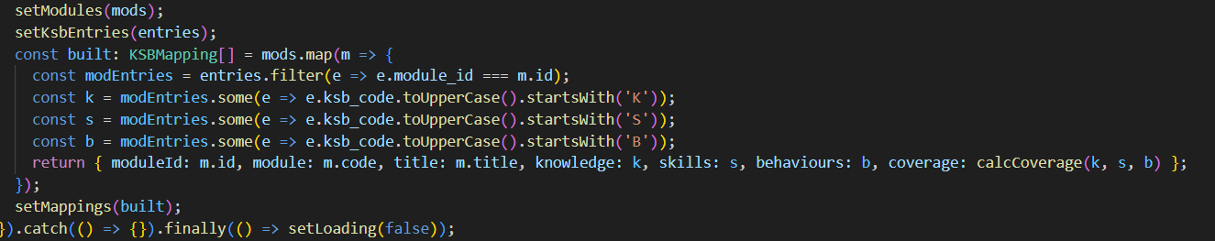
calcCoverage(k, s, b) function converts three Boolean flags to percentage, by having 1/3 weights each would give simple, equal weighting contributing equally to coverage. The .filter(module_id) allow the scope entries to a single module before checking, the Array.some(startsWith(‘K’)) returns true as soon as any element satisfies the predicate, as soon as the K entry is being found the rest of the array is not being checked. While .toUpperCase() normalizes KSB codes before prefix matching, which makes a check on the case insensitivity preventing data entry errors from breaking out the matrix. Finally the coverage is being calculated in the React component and not pre stored in database, which means the data is up to date as the entries are added or deleted without requiring a database trigger.
8.2.6 Dahsboard stats API
A single dashboard tailored for each role, rather than six separate endpoints. One endpoint returns different data that is shaped based on the role, which reduces the API calls from frontend making dashboard load.
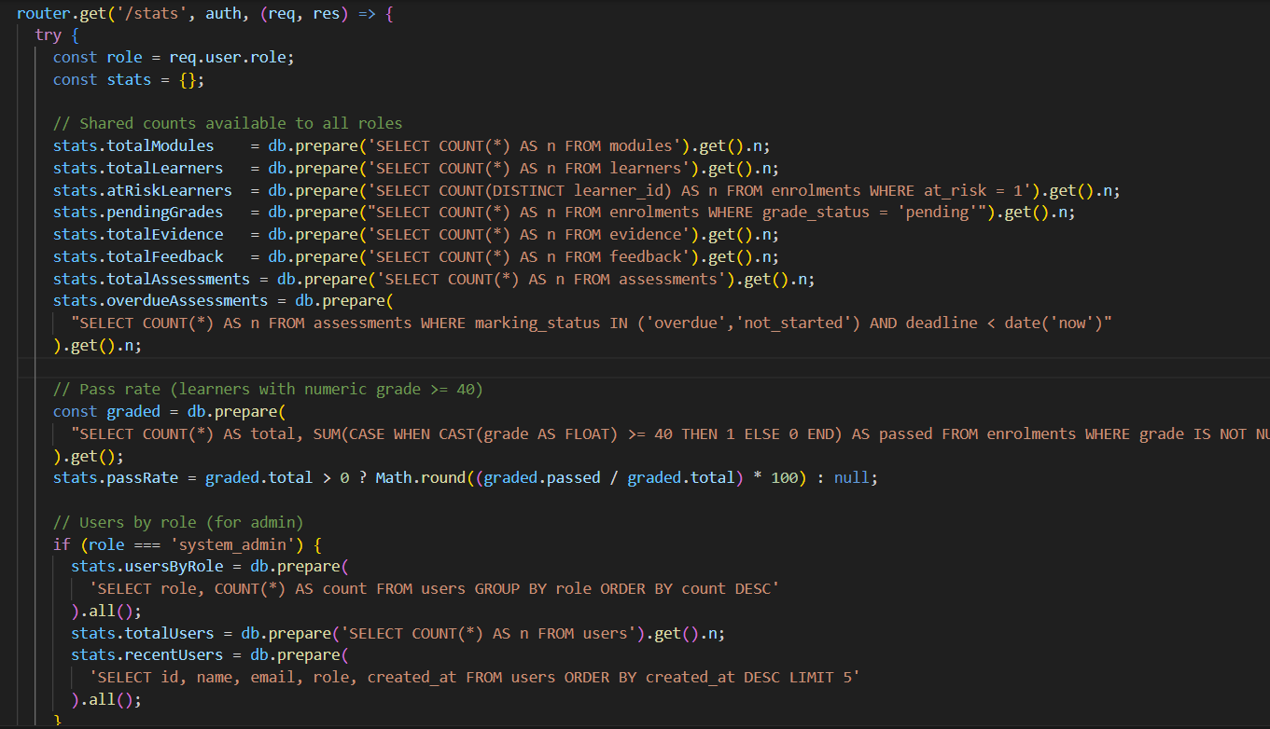
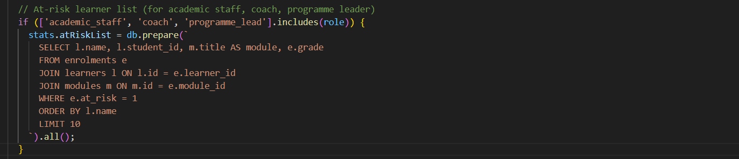
totalModules, totalLearners, atRiskLearners and passRate are being computed for every role. CAST(grade AS FLOAT) allows the grade values to be stored as TEXT in SQLite as it allows numerical comparison with non-numeric grades. If no grades have been imported the total graded enrolments is 0, passRate returns null rather than NaN or 0is being achieved through passRate null guard. Role === ‘system_admin’ allows only admin to see add user analytics. The at risk list is visible to all roles that is achieved by .include(role)
9. Testing Requirements
9.1 Testing Strategy
A credible academic evaluation for the prototype can be built from four complementary methods: heuristic review, task-based usability testing, accessibility checking and a short post-test usability questionnaire. This creates a stronger evidence chain than relying on opinion or visual polish alone.

Method | Purpose | Participants / artefacts | Output
Heuristic evaluation | Identify interface issues early using recognized design principles. | 3–5 reviewers comparing the prototype against usability heuristics. | Issue list ranked by severity (Nielsen Norman Group, 2022; Nielsen Norman Group, 2024).
Task-based usability test | Measure whether typical users can complete key workflows. | Programme lead and academic-staff scenarios using dashboard, grade import and evidence log. | Completion rate, time on task, observed errors and comments.
Accessibility review | Check the prototype against core accessibility expectations. | Keyboard testing, colour/contrast checks, table and form review against WCAG 2.2. | Accessibility findings and remediation list (W3C, 2024).
SUS questionnaire | Capture a quick, comparable measure of perceived usability. | Post-test questionnaire completed by participants. | A numerical SUS score with qualitative comments (Brooke, 1996).

9.2 Functional test scenarios
ID | Requirement
FT1 | Uploading valid CSV grade file- verifying the records imported, refreshed student overview table and at risk being flagged correctly.
FT2 | Upload CSV with invalid rows- display error banner
FT3 | Add KSB entry- matrix updates being verified and coverage % is recalculated
FT4 | Generate schedules- system verifies that excluded weeks do not appear in the output table
FT5 | Login as employer- System displays verified dashboard, feedback.
FT6 | Create a new user account as System admin- verify user list, login works with provided credentials with correct role.
FT7 | As a Programme Leader download necessary xlsx files with live data

9.3 Non Functional test scenarios
ID | Requirement
NT1 | Verify passwords are encrypted after user creation – confirm plain text password is not persistent
NT2 | Dashboard loads with limited time after user logs in
NT3 | Use non-CSV file to import grade- system verifies and rejects the upload with error message
NT4 | Ensure imports are completed in less than seconds
NT5 | Check Colour contrast of all status badge and stat card values
NT6 | Ensure the system is assessable for the assigned roles

9.4 Acceptance Criteria
- No roles can access data or perform operations outside the permissions set.
- WCAG 2.2 AA compliance confirmed for all upload components, forms, tables and dashboards
- All audit log entries are created correctly for write operations across system.
- All functional requirements pass the test before release.
- SUS usability score > 68 being achieved across test participants
- Grade imports validations correctly reject invalid rows without corrupting valid data

10. Deployment & Environment Setup
Requirement | Version | Purpose
Node.js | V18 LTS or above | Runtime for both backend and frontend build
npm | V9+ | Package manager for both workspace
SQLite | V3 | Database engine- no separate installation required
Git | Latest | Version control and Project cloning
Web Browser | Chrome/ Firefox/ Edge | Client browser

11. Deliverables
Deliverable | Format | Description
Full Source code repository | ZIP/ Git | Frontend+ Backend+ Database schema
Working MVP | Running App | Functional interfaces of all roles
Populated demo database | clarity.db | SQLite database pre-loaded with sample learners, modules, grades for all six roles
SRS | Word/ PDF | This document with full functional and non-functional requirements
UI/UX Research Report | Word/ PDF | UX research, accessibility analysis

12. Future Enhancements
There are future enhancements recommended beyond MVP phase as below,
Two factor Authentication for all user logins along with session timeout and automatic logouts after configurable inactivity period. Option to have password reset flow via email. A Single Sign On integration with institutional identity providers would be authentication and security enhancement on the application.
Integration of Cloud object storage for evidence file upload, replacing local file system storage. Role based multi tenancy that supports for multiple institution by sharing the same deployment with strict data isolation. A docker containerization for reproducible development and deployment environment. Global search bar for wide search across learners, modules, evidence and assessment. Implementation of self-service portal allowing students to view own progress, targets, and KSB mapping. In app notification centre for overdue tasks, new feedback and session reminders Would be the suggested future enhancement.

References
Brooke, J. (1996) “SUS: A quick and dirty usability scale.” In: Jordan, P.W., Thomas, B., Weerdmeester, B. and McClelland, I.L. (eds.) Usability Evaluation in Industry. London: Taylor & Francis.
GOV.UK (2025) Publishing accessible documents. Available at: GOV.UK guidance.
GOV.UK (n.d.) Tables. Content design guidance. Available at: GOV.UK guidance.
GOV.UK Design System (2025a) File upload. Available at: GOV.UK Design System.
GOV.UK Design System (2025b) Error message. Available at: GOV.UK Design System.
GOV.UK Design System (2025c) Error summary. Available at: GOV.UK Design System.
GOV.UK Service Manual (2018) Understanding WCAG. Available at: GOV.UK Service Manual.
ICO (n.d.) Data minimisation. UK GDPR guidance. Available at: Information Commissioner’s Office.
ISO (n.d.) ISO 9241-11 Ergonomics of human-system interaction. Available at: ISO Online Browsing Platform.

